VPN Setup Windows 10

How to set up a VPN connection on a Windows 10 device.
- Go to the Windows icon/search box usually at the bottom of the screen.
- Type VPN into the search box
- The device will offer you several options. Select VPN settings by clicking on it
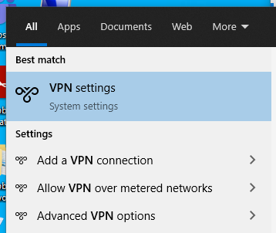

- In the settings pop up click on the plus button by ‘Add a VPN connection’
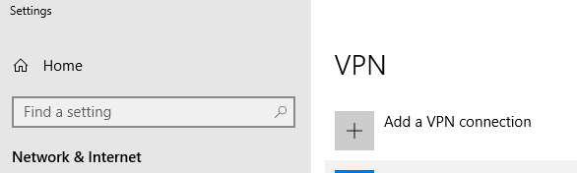

- A pop up appears – complete the boxes using the drop down selections where provided and typing the rest.
  - VPN provider – (Windows (built in)
  - Connection name - WNCConnect
  - Server name or address – wncconnect.wnc.ac.uk
  - VPN type – Secure Socket Tunneling Protocol (SSTP)
  - Type of sign-in info – username and password
  - User name (optional) – Do not fill this in
  - Password (optional) – Do not fill this in
  - Remember my sign-in info. - Recommend taking the tick out on a shared device particularly if there is little to no security on the device as we need to vigilant in protecting student data. Removing the tick will mean that it prompts for your username and password when you try to connect.
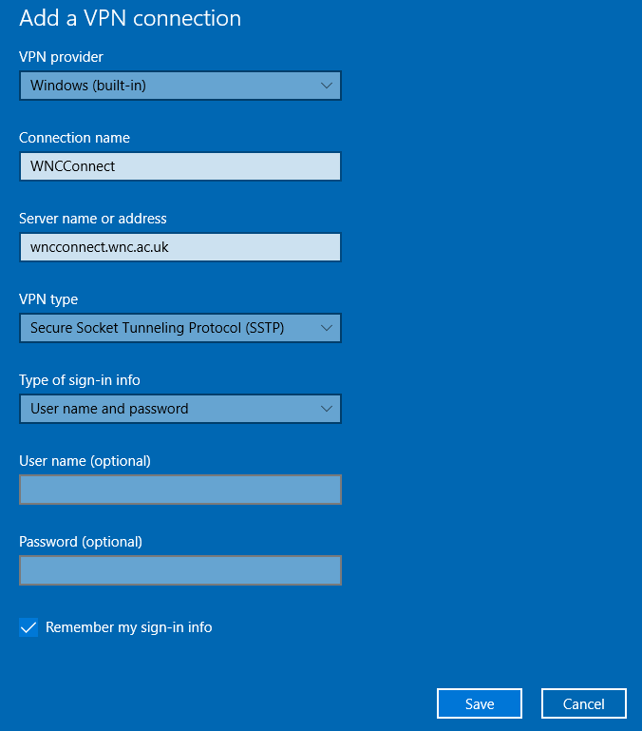

- Click Save

- On the VPN page there is an Advanced Options section
Allow VPN over metered networks
Allow VPN while roaming
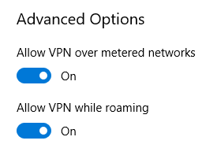
- Related settings
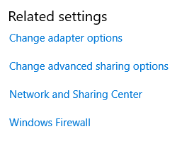
Click on ‘Change adapter options’.

- Right click on the connection you have just created – WNCConnect and select properties
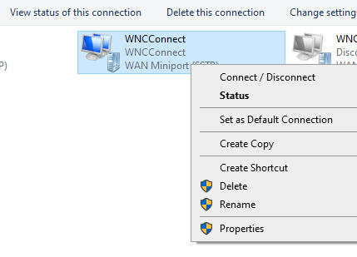

- Click on the security tab
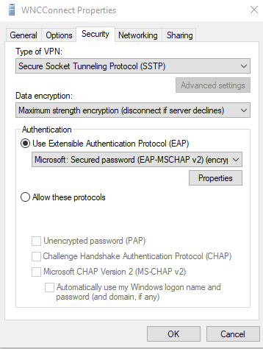

- Data encryption drop down menu select
Maximum strength (disconnect if server declines)
Authentication – select Use Extensible Autehntication Protocol (EAP) and on the drop down menu choose
Microsoft: Secured password (EAP-MSCHAP v2) (encryption enabled)

- Click the networking tab
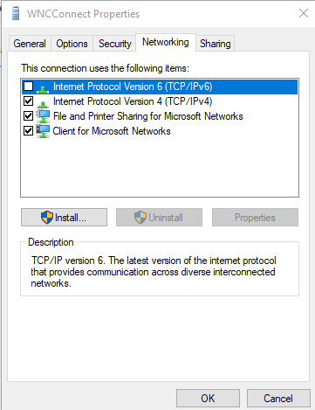
Make sure there is NO tick against Internet Protocol Version 6 (TCP/IPv6). If there is, take the tick out.
Click OK.

- On this same Change adapter options page look for your main network connection. It will either be Ethernet or wifi depending upon how you connect your device to the Internet.
Right click on your connection (the illustration is with Ethernet, yours may be different)
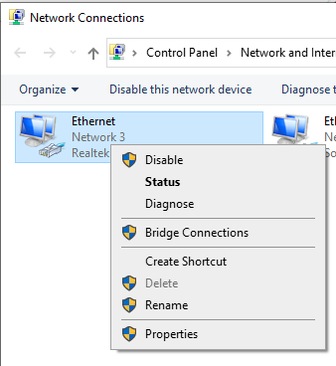

- Click Properties.
On the Networking tab look for Internet Protocol Version 6 (TCP/IPv6). If it is ticked in the check box, remove the tick
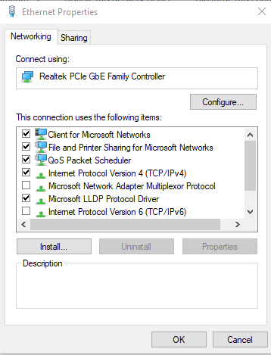
Click OK.

- You are now ready to test the connection

- Go back to the VPN page.
Click on the connection you have just created, WNCConnect. It will expand to show three buttons
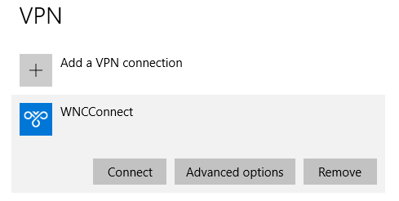

- Click the connect button.
A pop up will appear asking for your username and password
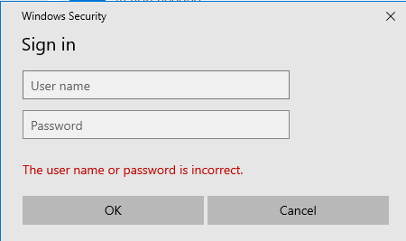
Enter your MS Teams username, (the same one as office.com and Moodle)
Enter your regular network password.

How to Connect
Once you have created a VPN connection and you return to the computer there are several ways to connect with it.
You can search for the VPN page as described above and connect as described above.
You can also look at the bottom right of your screen, click on the notifications icon
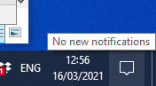
Then in the offered options click on VPN
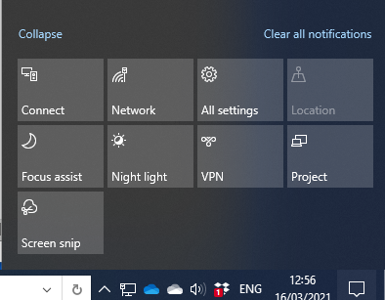

It may offer you the WNCConnect button, or it may take you to the VPN page. Click on the WNCConnect and then select Connect.
Remember to click Disconnect when you have finished with the college network, or simply shut down the computer.

The VPN will automatically disconnect after a period of inactivity. This is normal and is set to do so for security purposes. You can sign back in as normal to continue using your preferred connection method. We advise saving any documentation regularly to prevent any issues.

Trouble shooting
- If searching for VPN at the start does not work you can also search for settings or click the cog icon on the start menu. Then once on the settings page select Network and Internet.
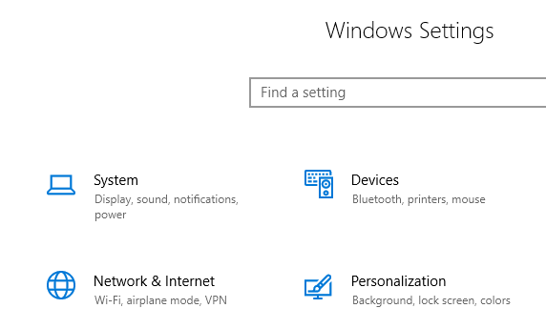
Once in the Network and Internet menu VPN will be on the left, click that and pick up from point 4 above.

- If you are struggling to connect, or it lets you in and drops off again almost immediately try rebooting your computer.

