Moodle Mobile App

There is a Mobile App available for Moodle.
It can be downloaded from the usual app stores.
For Android Devices visit the App store here.
For Apple Devices visit the App store here.
WNC is not using the QR code and we do not have push notifications enabled.
Follow your device’s guidance for installing the app.

How To Log in on the App

- Tap the app to open it.
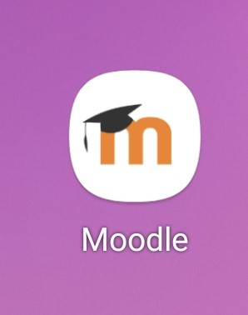
- Where it asks for site name put in
https://moodle.wnc.ac.uk
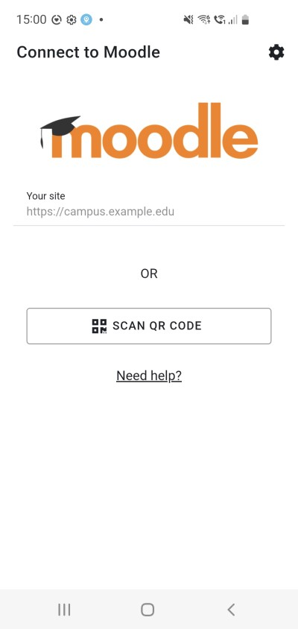
- Tap connect to your site
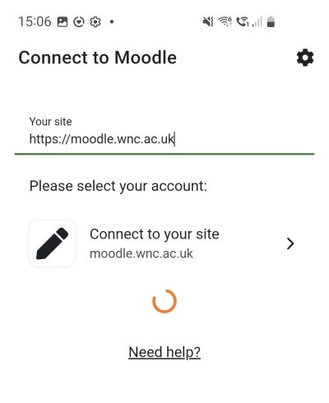
- Tap the OpenID Connect Button. If you can’t see it scroll down.
You will need to be very patient whilst the page arrives.
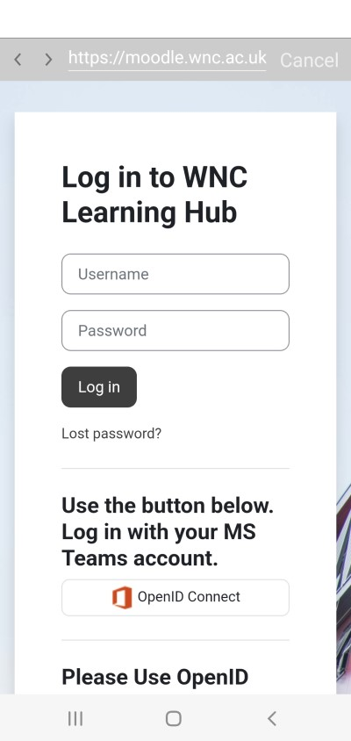
- Use the same credentials to log in as you do for Microsoft Teams. (Student id@students.wnc.ac.uk and your usual password).
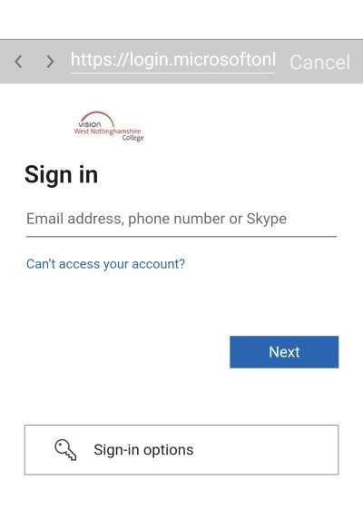
- The page will load.
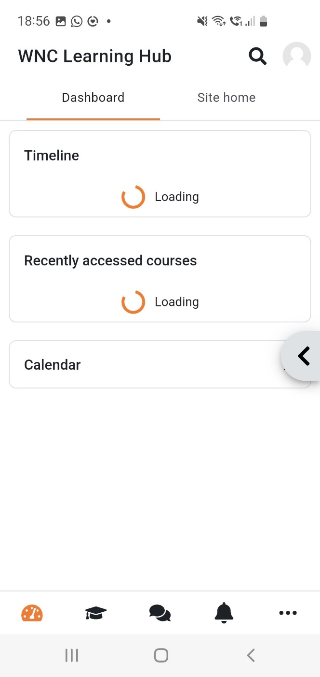
- Visit the My courses tab to see the courses you have enrolled in to.
