How to pay for your bus pass

We have several ways in which you can obtain your bus pass

- If your household income is less than £28,000 you will be eligible for a college bursary which will include your college bus pass. All you need to do is complete the online application which can be found on the main college website under student financial support or click this link https://www.wnc.ac.uk/Support-and-services/Financial-support.aspx complete the appropriate application and upload the evidence required.
- Sign into the wisepay system if your household income is over £28,000 by using the below instructions and pay the £105 subsidised fee for the bus pass.
- If you are unable to pay via wisePay you can pay directly to our bank account using the details below:

Account Name: West Nottinghamshire College
Account Number: 01203241
Sort Code: 309543
Quoting Reference: Student ID Number and Surname

Please also send an email to remittances@wnc.ac.uk if you use this method of payment stating the following information (if we do not receive the email we will be unable to allocate the payment to your student account and therefore unable to issue you with a pass for the bus)

Payee Name
Student Name (if different to payee)
Student ID Number
Date paid

- Contact the college by calling 01623 627191 and dial any of the following extension numbers 8040; 8536; 8039; 8169; 8081; 8189; 8187 and pay for the bus pass over the phone

Instruction for paying via Wisepay
Students will be sent an email to their College email address containing their WisePay username and password.
To find the email, go to https://wnc.ac.uk/ hover over the heading Students and click on Student Email (Office 365)

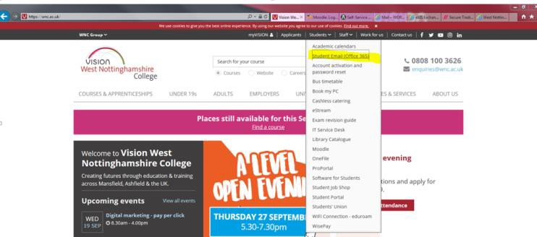

Enter your student ID number e.g. WOR07001597 (not case sensitive) this can be found on your offer letter using the ending below and click next
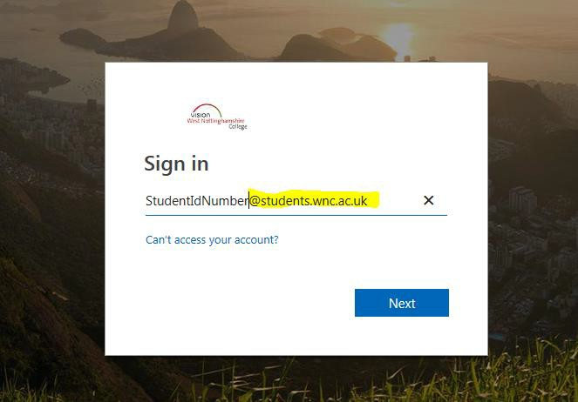

Enter your password which will be your student ID Number e.g. WOR07001597 (capital letters) and click sign in.
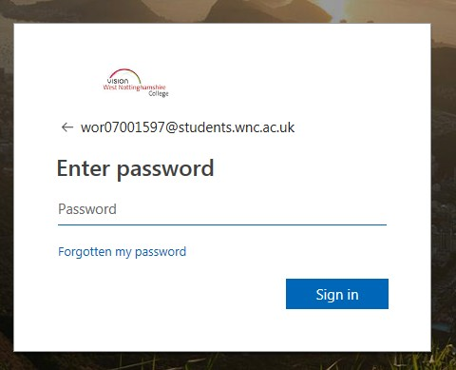
**If you do not have your log in details please call the Admissions team on 01623 627191 ext 8856 to request this information.
Once in, all mail boxes have 2 sections, a Focused area and one called other, if you cannot see the email straight away look in both sections until email has been located.
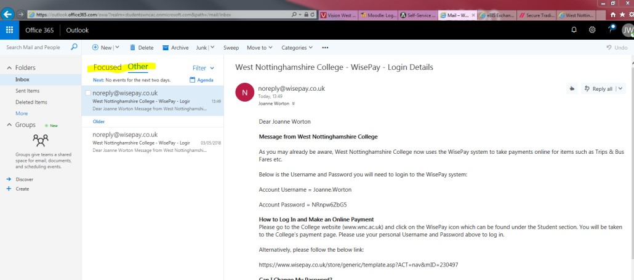

Now you have these details you can sign into WisePay
Go to the main College website click on the Bus Service icon:
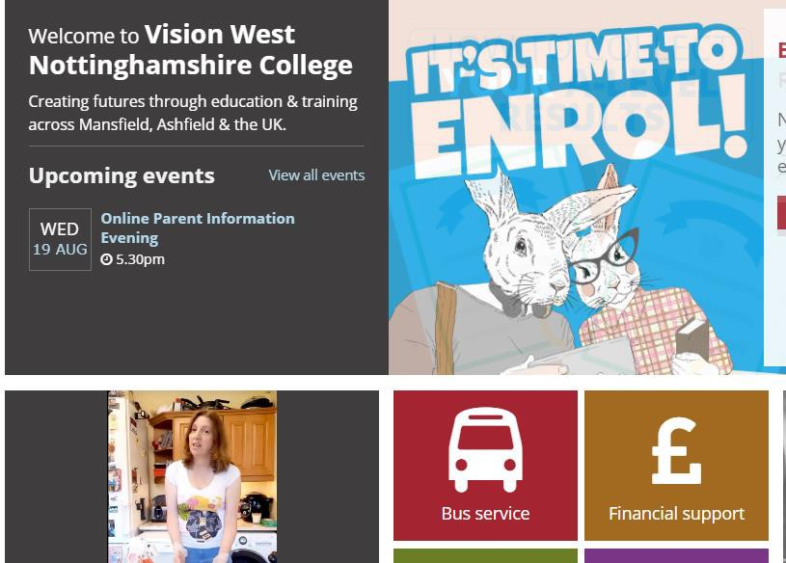
The next screen you come to will show the different routes, scroll down and click on the Paying for college buses button:

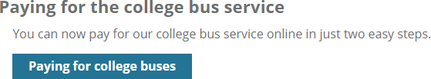

At the next screen you will see below. You will now have you Wisepay login details for Step 1 to get your Wisepay log in details. So go to Step 2 – press the link in this section which will directly take yo to the Wisepay website.
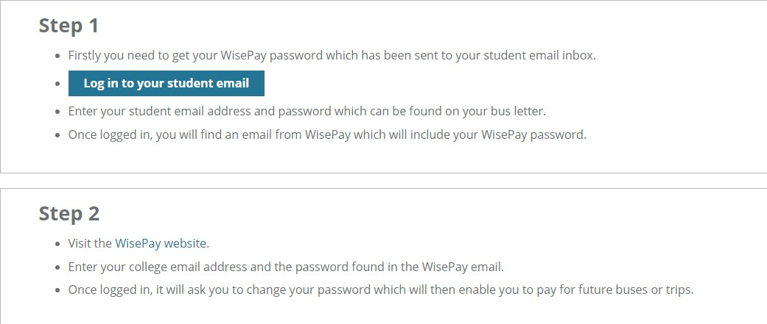
Once you have clicked on the link and you will be re-directed to:
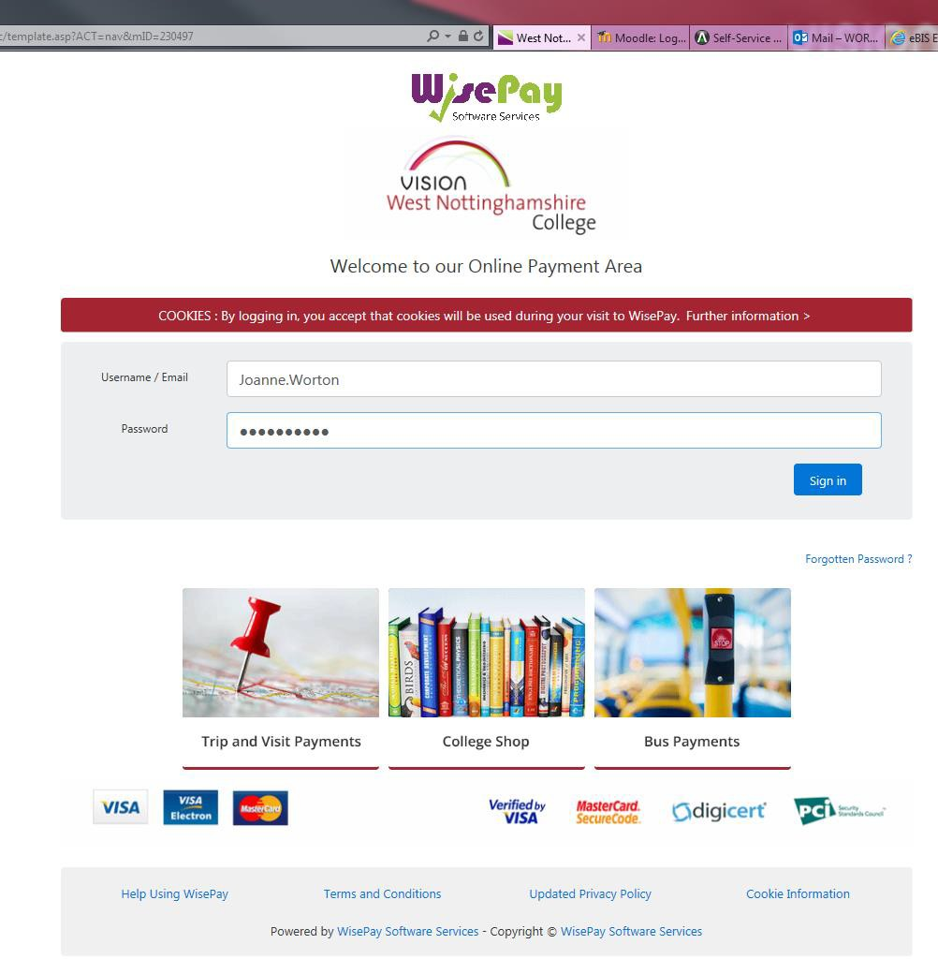

Enter your user name and temporary password in the email and fill in the details and click Sign in
At this point it is advisable to change your password to something more memorable by clicking on Change Password in the top red ribbon.
Scroll to the top of the screen and enter your parents name (if applicable) and provide a telephone number in case we need to contact you regarding your payment.

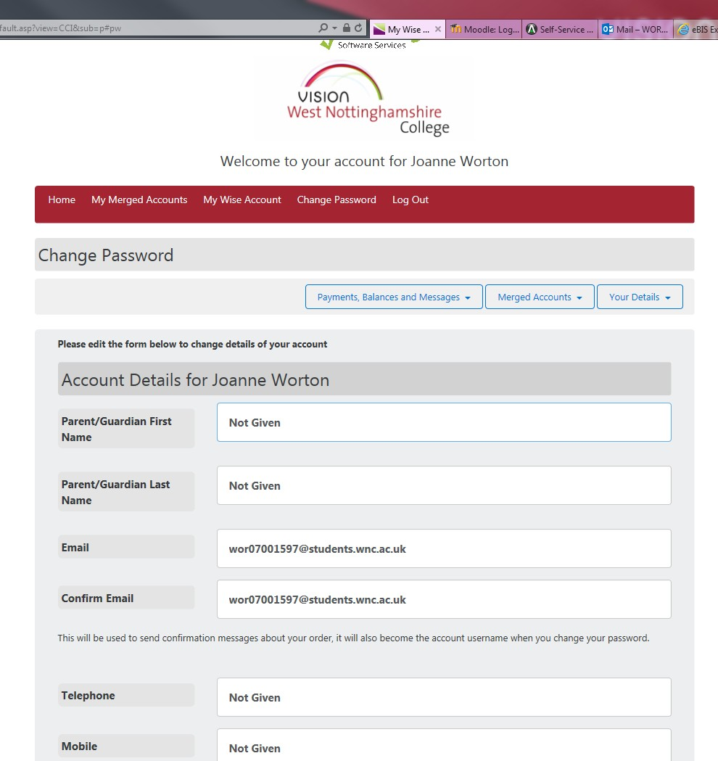

Scroll down and change the Confirmation of Password Change to Yes and enter your new password twice and click Save Account Details.

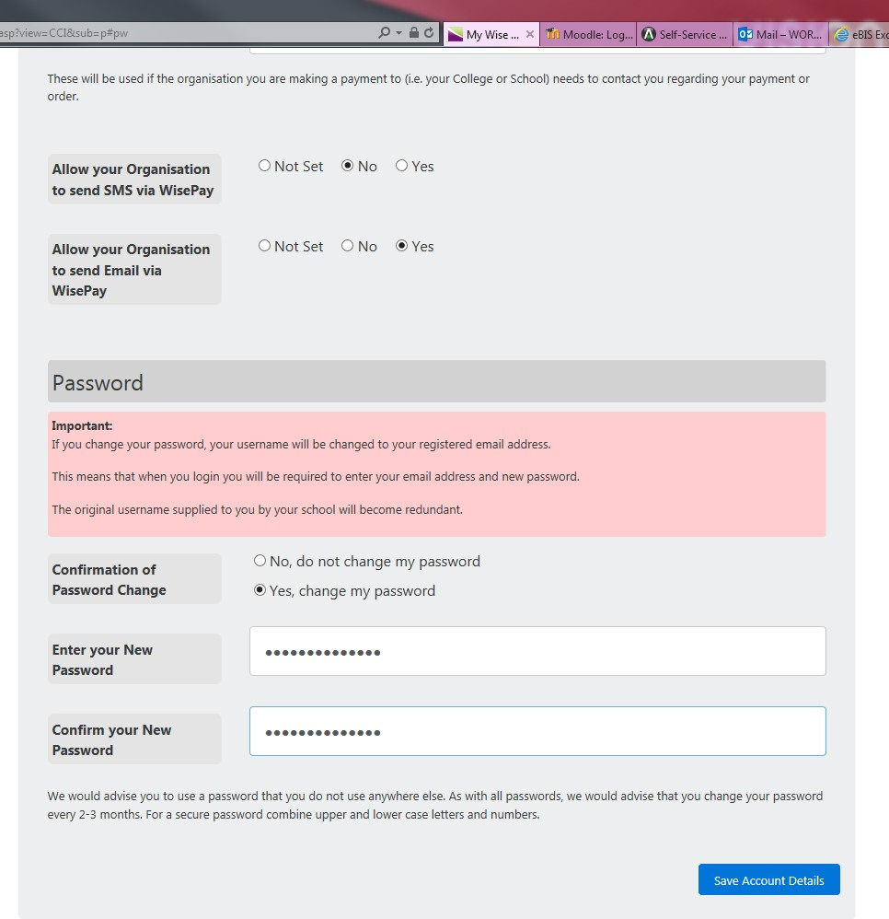

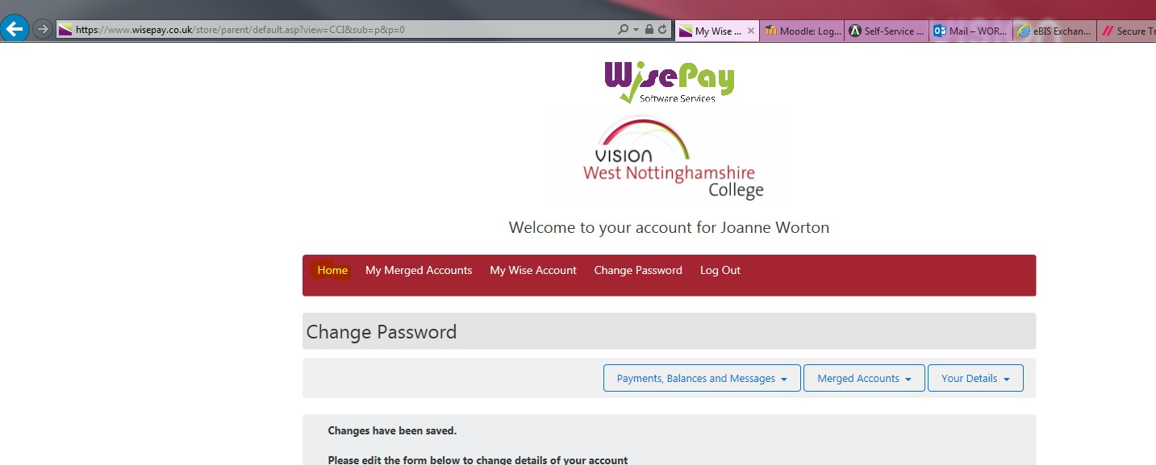

Scroll back to the top and click Home to return to the main menu You will be taken to the Wisepay Home Screen
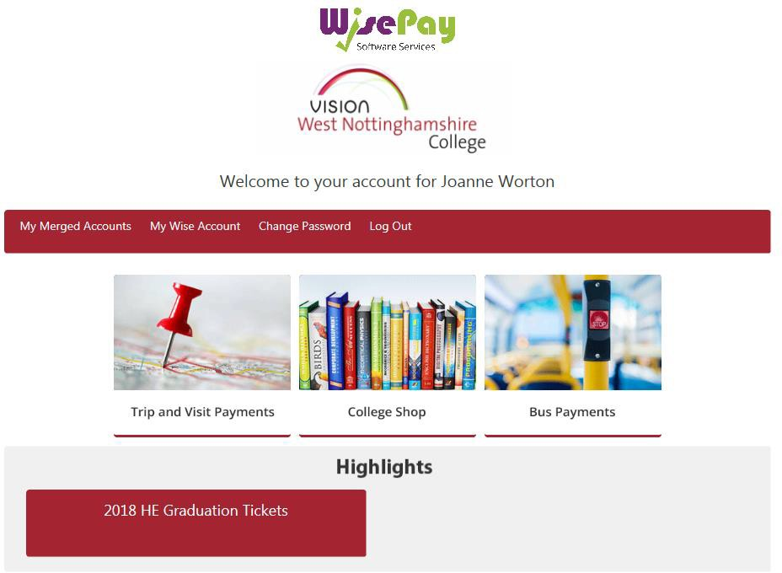

Click on the Bus Payments icon
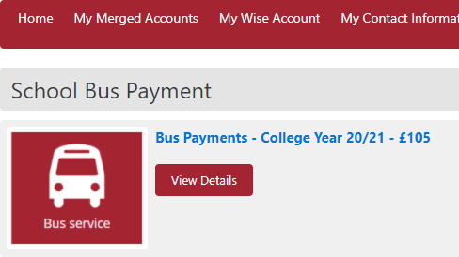

If you click on View details you will be given further details. Example below:

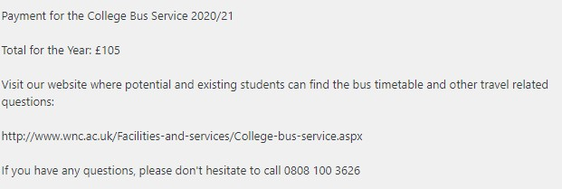

Click on the Purchase button which shows under the details.
You will see the screen below. You can either continue to shop e.g. for items required for the course or for trips. Otherwise, click Proceed to Checkout.
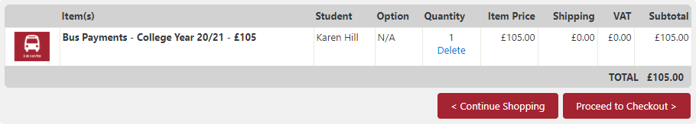

Enter email address as this is where the confirmation of payment will be sent. Click Yes that you agree to the T&Cs and confirm order details are correct.
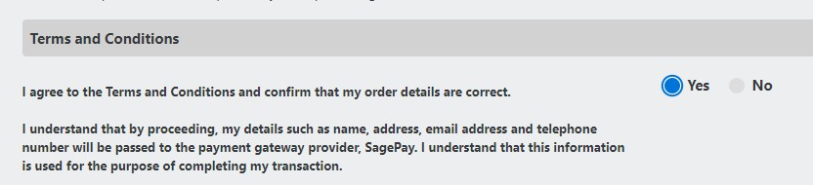

Click on Confirm Payment.
You will be taken to the Sage Pay
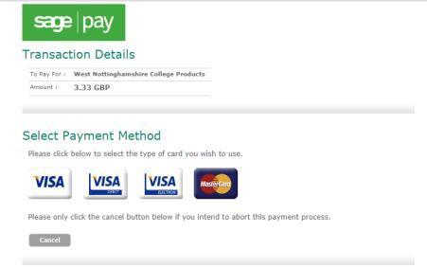
Select type of card you will use and it will take you to the page to fill in your card details etc. Click to process the payment and you will get a screen with the Transaction Details/Your shopping basket (shows what you have purchased)/Card Details.
You can go back if you have made an error to correct or you can cancel at this stage. If you want to continue click Pay Now.

Once payment is complete you will be brought back to the below page
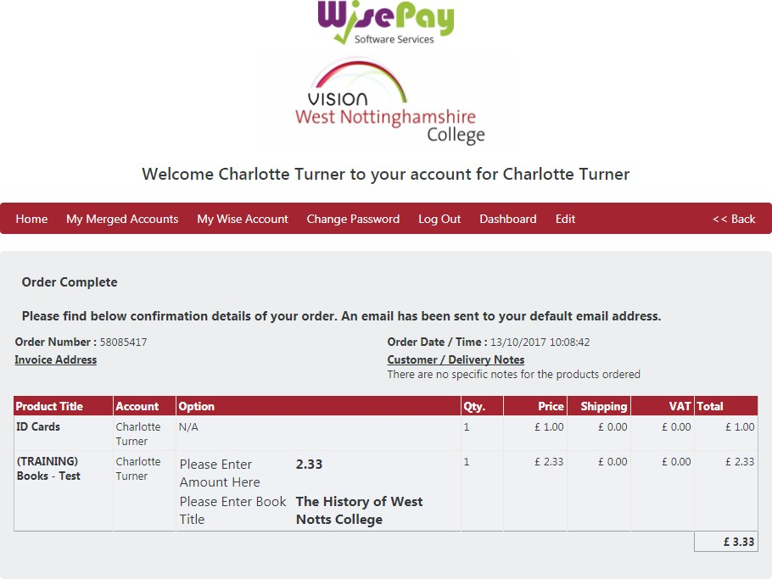

If you click on My Wise Account in the menu bar you will see your payment history.
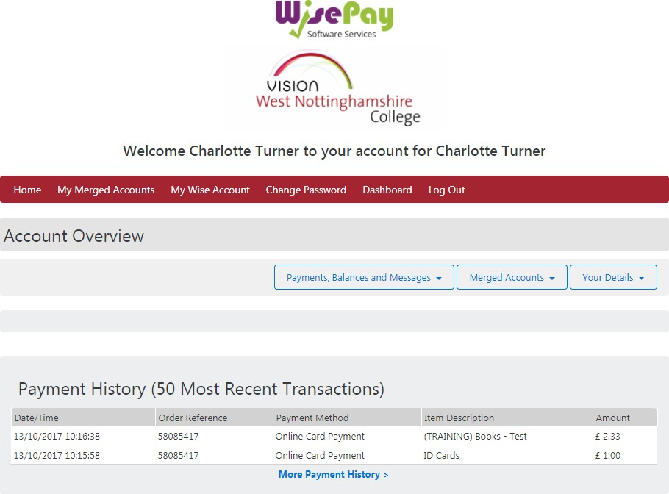

Log out and your payment has been completed.

