How to use Immersive Reader function – for Word online documents:

Please ensure you have either your PC speakers switched on or are wearing headphones.

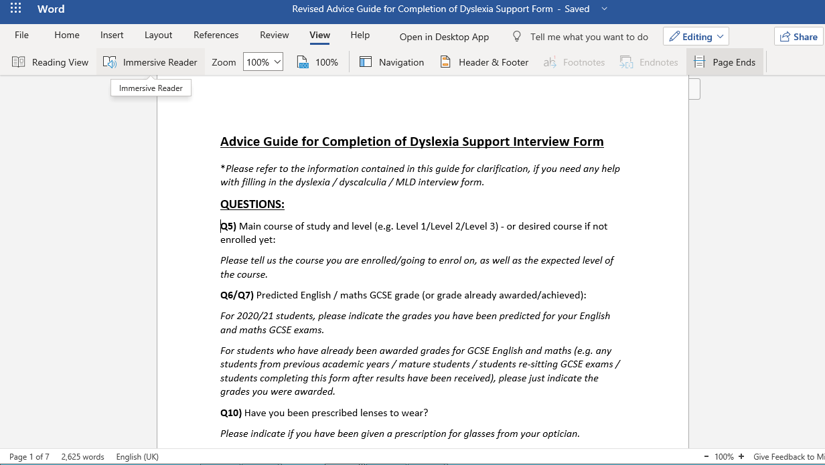
- Click on the ‘View’ tab at the top / middle of the screen.

- Position your cursor (or just click) before the first word of the text.

- Click on ‘Immersive Reader’

- Wait for the Immersive Reader to load. Your screen should look like this (below) after it has loaded.
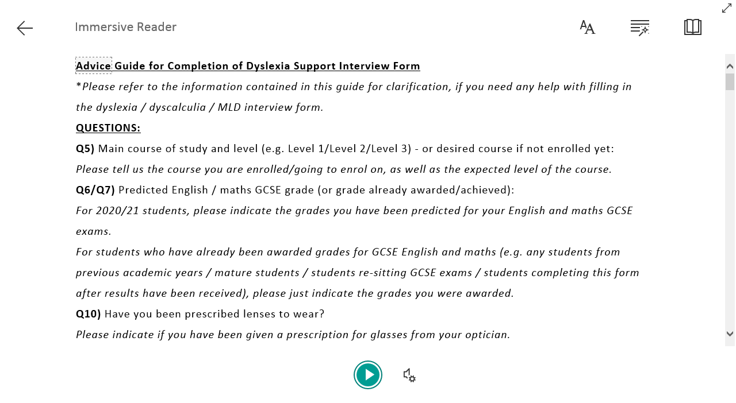

- Click on the ‘Play’ arrow to hear the text read aloud. To change the voice settings, click here.
If you do click on the ‘Voice Settings’ icon, you will see a box like the one below. You can see that changing the voice settings allows you to alter the speed of the voice and whether you hear a male or female voice.
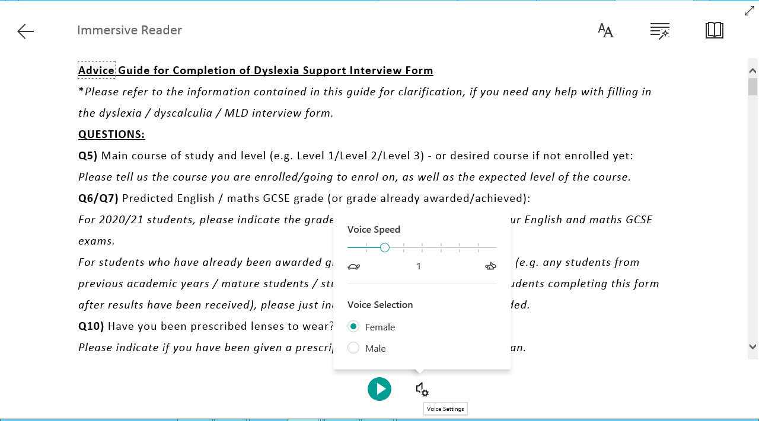

- Clicking in here will give you Text Options

- Clicking here will give you Text Preferences:

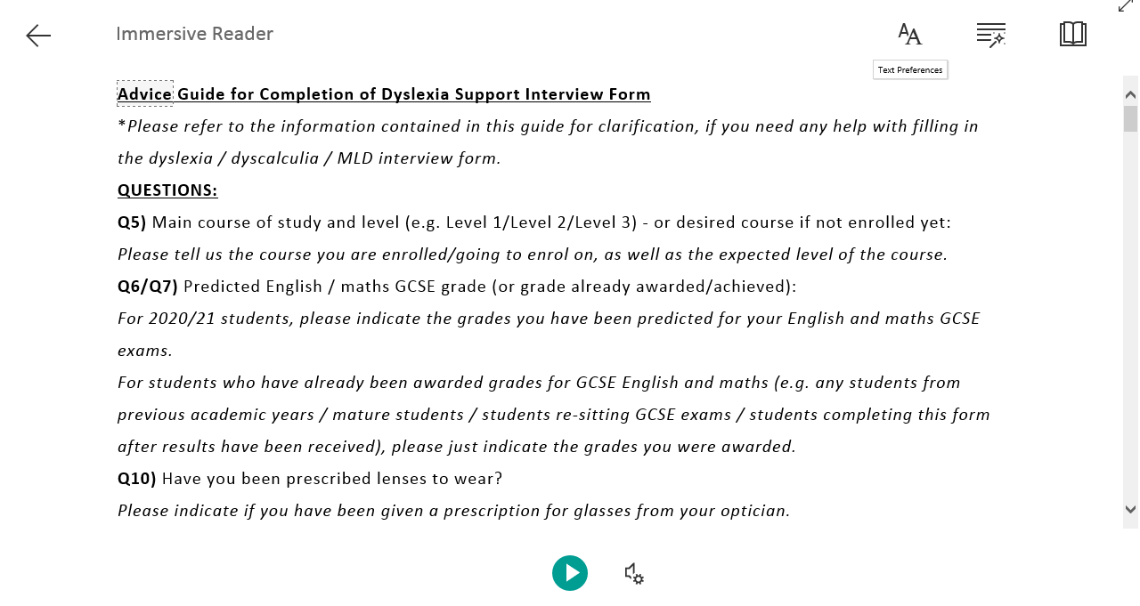

- Text preferences available include changing font, font size, spacing and the colour of the screen (shown below):

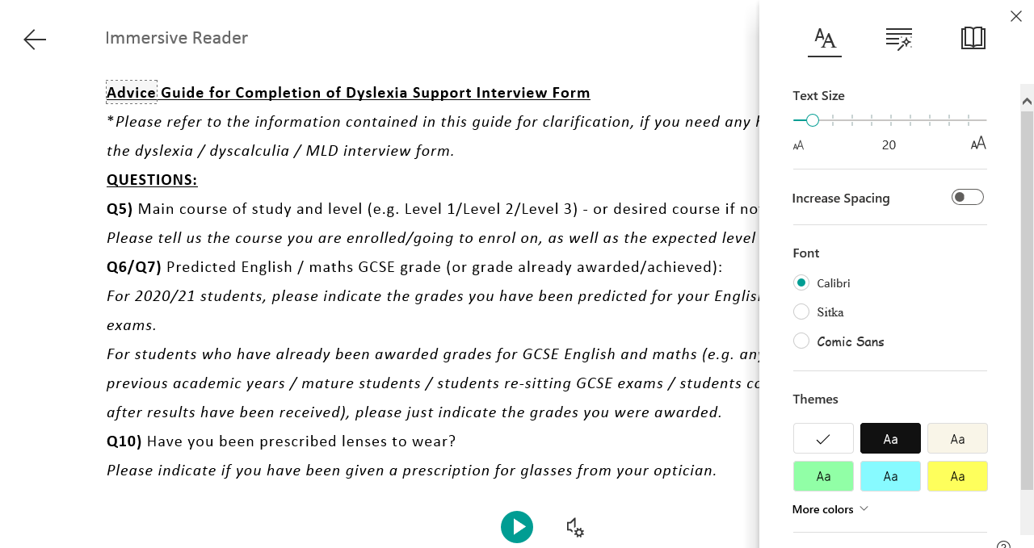

- Clicking here will give you Grammar Options:

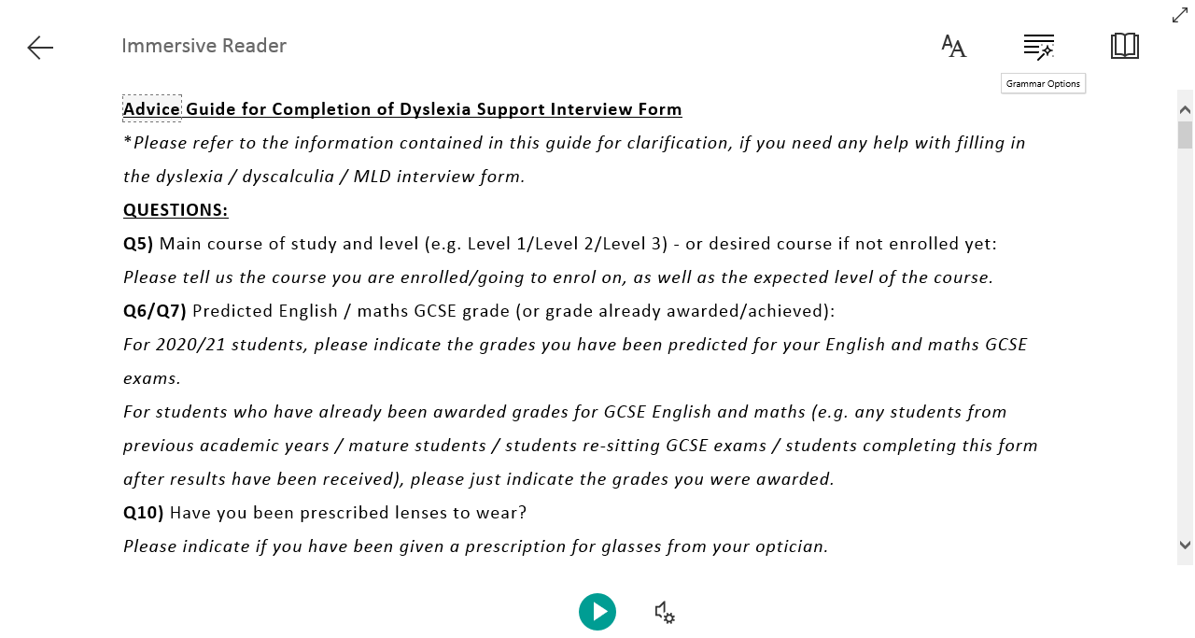

- Grammar options available (shown below) include the option of being able to break a word into its separate syllables (as well as being able to highlights different types of words in different colours, which can be useful in English assignments)
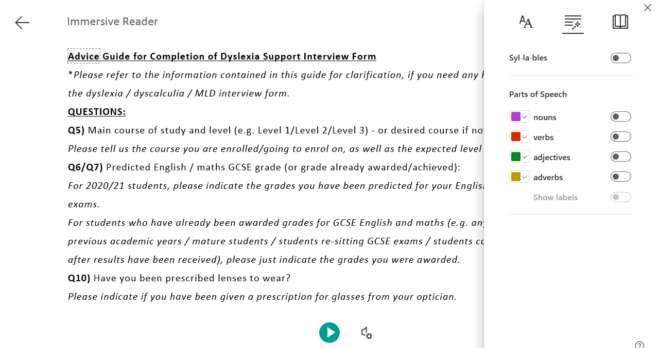

- Clicking here will give you Reading Preferences:

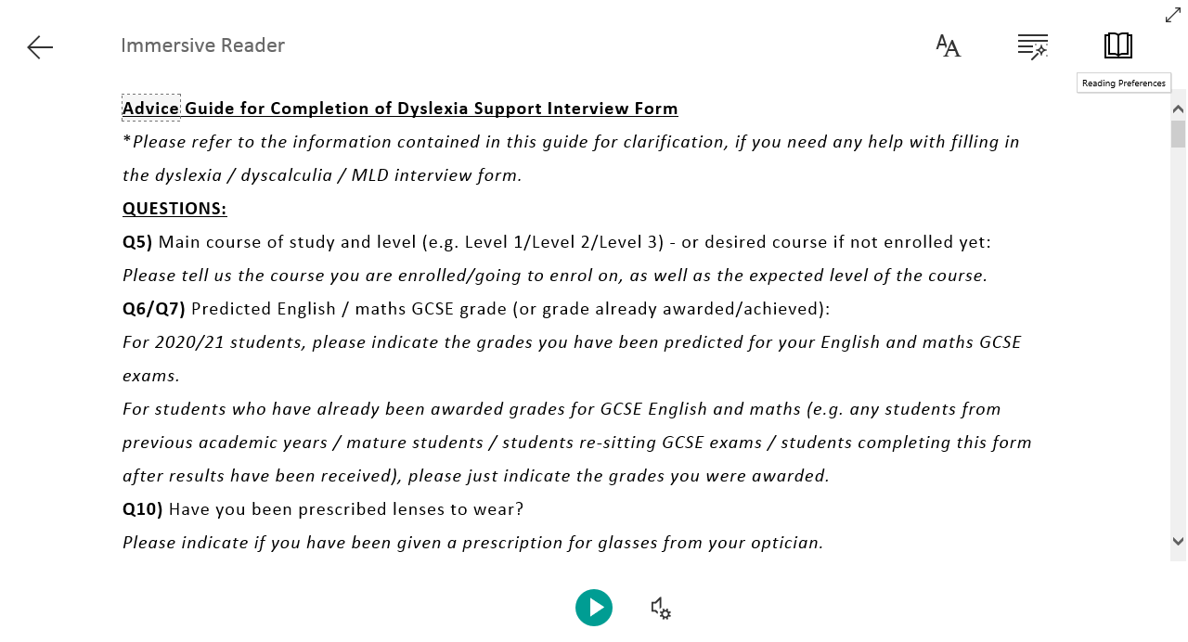
- Reading preferences here include giving you the option to choose whether you want the text to only display each line or paragraph/question, as you read it (the rest of the text is masked). This is under ‘Line Focus’. You can also translate the text into another language.

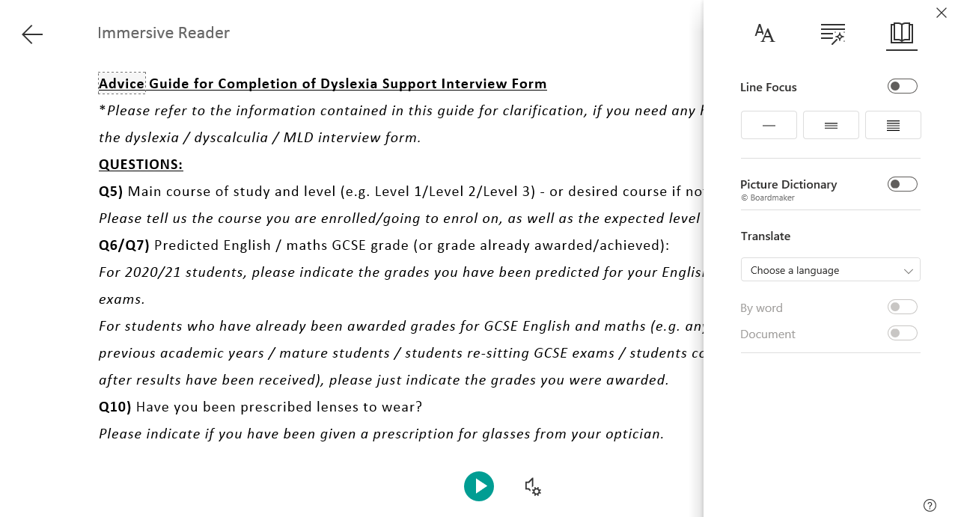
As will all new software, it is advised that you take some time to explore the functionality to find the options which best suit you.

