Esports Kit list
As of September 2023 intake we will be requiring students to purchase an Esports polo shirt via (Liss Sport) and a team jersey via ESK for internal/external tournaments.
You will be expected to have ordered your kit at the end of September.
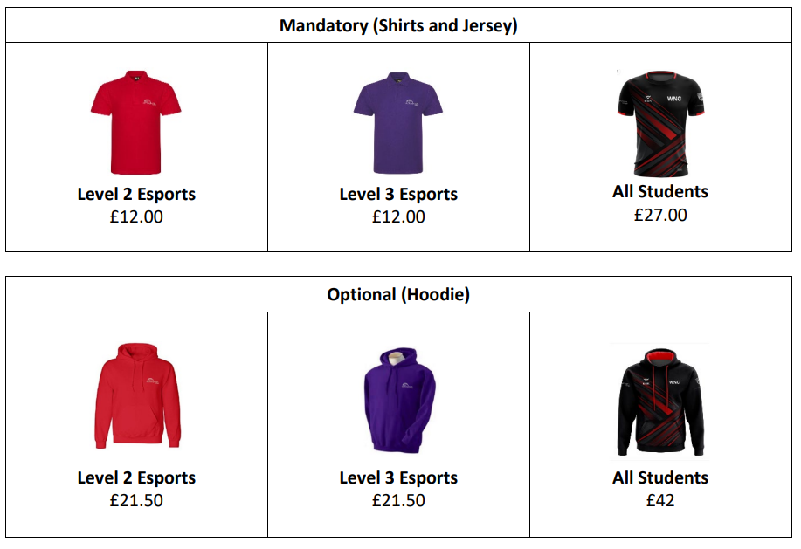
Please DO NOT order your kit before enrolment. Links to the suppliers will be provided once you have enrolled onto the course.

You will also require a basic sports kit for sports-based modules within the course. Please ensure that you have access to a polo shirt, shorts/joggers, and appropriate footwear.

You will be meeting businesses and clients; therefore, it is important that you have appropriate formal clothing for these situations but notice of this will be given when required.
You are allowed to bring your own computer peripherals such as keyboard, mouse, mouse mat, controller, and headphones. There will be standard ones provided by college for all students to access.
You should ensure if possible that you have accounts on the following four Esports games:
- League of Legends
- Overwatch 2
- Rocket League
- Valorant
You should also register for a discord account - this will be used for communication with your studies. Please be responsible in choosing your account names and gamer tags.
It is preferred that students have a computer device at home alongside an internet connection, if this is not possible it is advised that a conversation is had with the course team prior to application.
For further information please contact Scott Smith and Wayne Johnson (Course Tutors)
Scott.Smith@wnc.ac.uk | WayneLeslie.Johnson@wnc.ac.uk

