A Levels
Kit list
Only a few subjects have specified particular equipment you will need to buy before the course.

Business
A calculator (it doesn’t need to be a scientific one)
Maths
Students need to have this scientific calculator – Casio fx-991EX
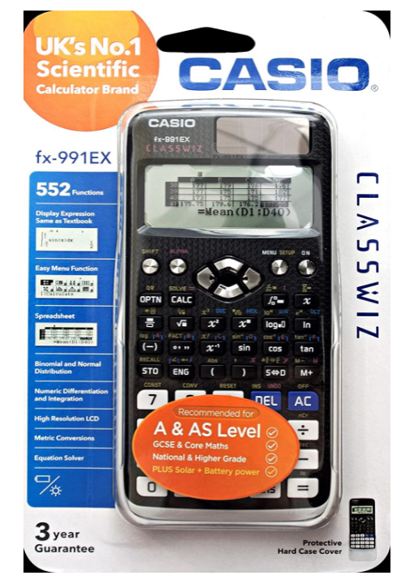
Biology, Chemistry, Physics
A scientific calculator (any type)

