Set up email in Android

Logon Details
Email Addresss: |  | ABC12345678@students.wnc.ac.uk
Password: |  | The password you use to log into college computers
User Name: |  | ABC12345678@students.wnc.ac.uk
Domain |  | westnotts.ac.uk
Server: |  | outlook.office365.com
Video to setup Mobile phone

Set up email with the built-in Android email app
Note: Android mail apps may look different across different devices, and the directions given may not exactly match the options that you see. Use these steps as a guide or consult the manufacturer's help for your particular device. You can also choose to use the built-in Gmail app if your Email app is not available.
- Tap Settings > Accounts > Add account > Email.
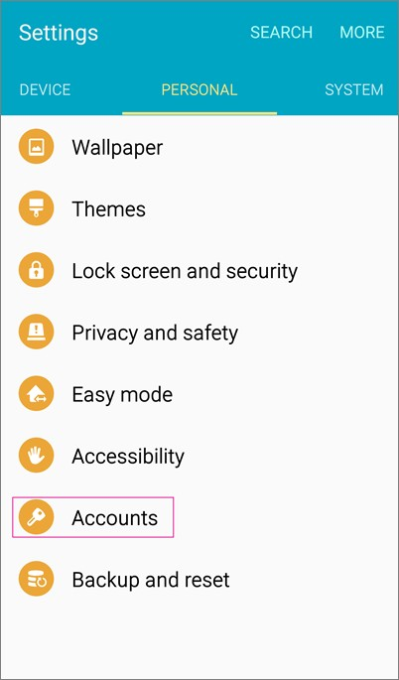
- Type your full email address, for example tony.smith@wnc.ac.uk, type your password, and then tap Next.

- Select the Exchange option.

- Depending how the Office 365 administrator in your organization set up your account, you might receive a message about additional security features. Select OK to continue.
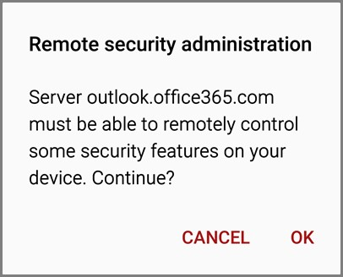
- Once the device verifies the server settings, the Account Options page opens. Accept the defaults or select the options for how you want to receive and send your mail, and then tap Next. (You may need to scroll down to see Next.)

- On the Set up email page you can change the name of your account. When you're finished tap Done.
If you synced your calendar and contacts in step 5 you can go to those apps on your phone to view any items that might be there. If you synced tasks as well, you should see them in the calendar app on your device. It might take a few minutes for everything to sync.
If your device can't connect make sure you typed your email address and password correctly and try again. If you still can't connect try setting it up following the Manual Setup below.

Set up email with Manual Setup on Android

If you are unable to set up your email account with the above steps because your Android device is incompatible with the Outlook mobile app or the options for the built-in mail app are not working, try manual setup. If you continue to experience problems, see Troubleshoot email setup on mobile.

Set up your email address manually
In order to complete the manual set up process, you may need information from your email provider.
- Tap Settings > Accounts > Add account > Email.
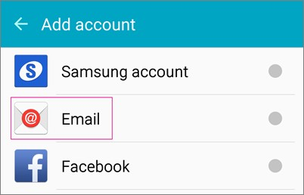
- Type your full email address, for example tony.smith@wnc.ac.uk, type your password, and then tap Next.

- Select Manual.

- Review the settings on the Exchange server settings page and update if necessary.
o Email
Make sure your email address is in this box, for example, tony.smith@wnc.ac.uk

o Domain\Username
Type your full email address in this box, for example, SMI101101@westnotts.ac.uk. If Domain and Username are separate text boxes in your version of Android, leave the Domain box empty, and type your full email address in the Email box.

o Password
Use the password that you use to access your account.

o Exchange Server
The server name for Office 365 for business is outlook.office365.com.

o Make sure the Use secure connections (SSL) box is checked.
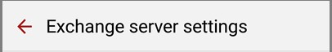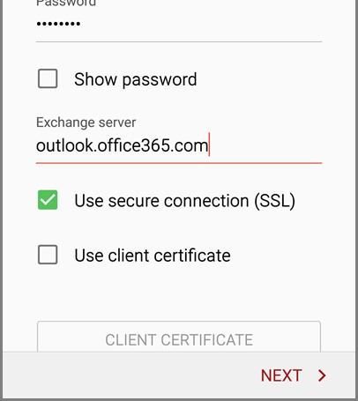
- Tap Done.

- Depending how the Office 365 administrator in your organization set up your account, you might receive a message about additional security features. Select OK or Activate to continue.
- Accept the defaults or make changes for how you want your account to sync on your device. When you're finished, swipe to the bottom and tap Next.

- On the Set up email page you can change the name of your account. When you're finished tap Done.
If you synced your calendar and contacts in step 7 you can go to those apps on your phone to view any items that might be there. If you synced tasks as well, you should see them in the calendar app on your device. It might take a few minutes for everything to sync.

Set up email in the Outlook for Android app
Stay in touch with friends, family, and coworkers using the Outlook for Android mobile app. Send and receive email, manage your calendar, and much more.

Set up Office 365 email in Outlook for Android
- Open Outlook for Android on your device. Tap Settings > Add Account > Add Email Account.

- On the Add Account page, enter your email address and tap Continue.
In most cases, Outlook will be able to automatically detect your email provider and configure your account for you. If you're prompted to choose your account type, choose Office 365 from the icons shown.
- Enter your password and sign in to connect your account. You may also be asked to enter a name and description of your account.

- If you are prompted to enter additional details such as server settings,
 | Server name | Port | Requires SSL (TLS)
Incoming Mail (IMAP) Server: | outlook.office365.com | 993 | Yes
Incoming Mail (POP) Server: | outlook.office365.com | 995 | Yes
Outgoing Mail (SMTP) Server: | smtp.office365.com | 587 | Yes
NOTE: If you set up your email using IMAP or POP settings, your calendar will not sync
- Outlook for Android may request access to info like your calendar and contacts. Tap Yes or Allow to grant these permissions. If your organization has set up security policies for you, tap Activate.
You are now ready to use Outlook for Android!
Logon Details
Email Addresss: |  | Firstname.lastname@wnc.ac.uk
Password: |  | The password you use to log into college computers
User Name: |  | LAS012345@westnotts.ac.uk
Domain |  | westnotts.ac.uk
Server: |  | webmail.ac.uk

