College Wifi On Android Devices

Android devices can vary by model, hence the instructions might not be exact
First connect to Eduroam then install the college certificate.
If the android 11 instructions don’t work try the android 10 instructions and vice versa.

Adding Eduroam

Android 11
Goto the play store and install the get Eduroam app
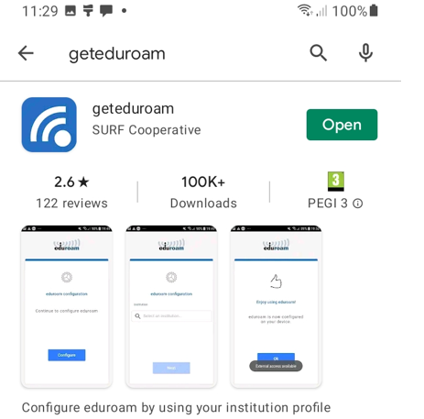

Run the app and search for west Nottinghamshire college on the institution page and next
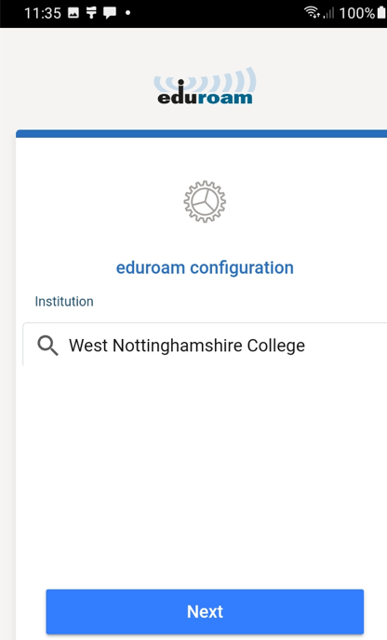

Sign in with username @westnotts.ac.uk (eg. Abc2021000@westnotts.ac.uk) and your regular college password
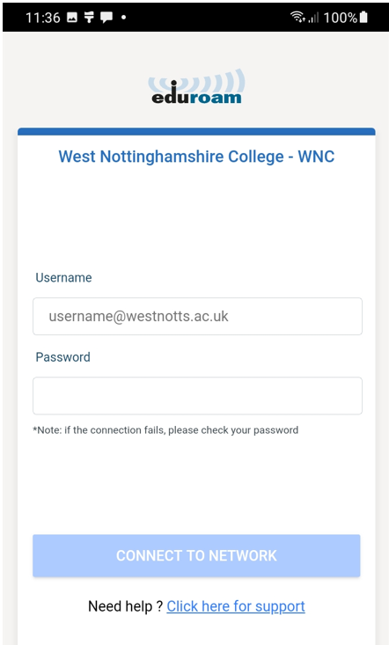
This should add Eduroam to the wireless networks with all the settings and connect when onsite

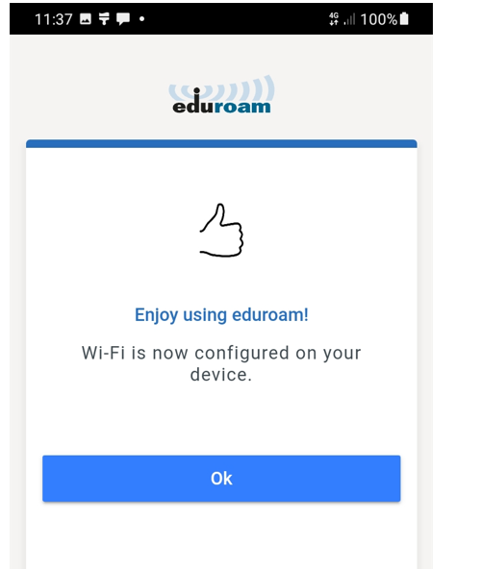
Android 10 and below
Firstly go to the play store and search for the Eduroam cat app and install
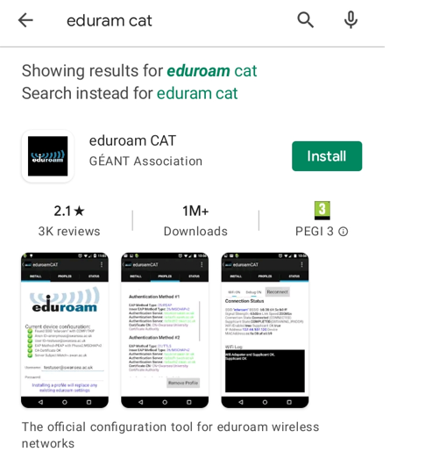
Then browse the internet and search for the Eduroam cat webpage https://cat.eduroam.org
Select the Eduroam installer option – search for west Nottinghamshire college in the list
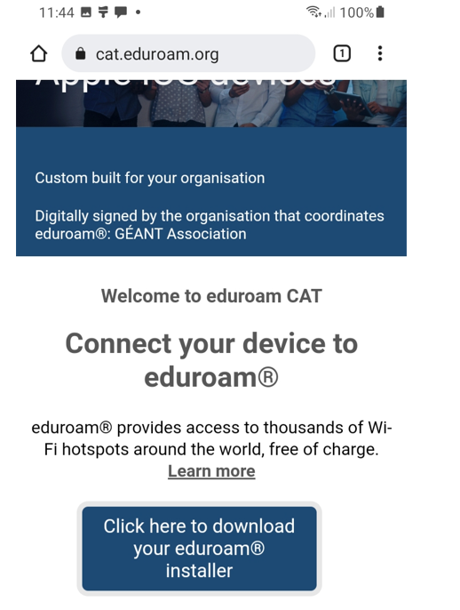
Select the blue button for the version of the phone.
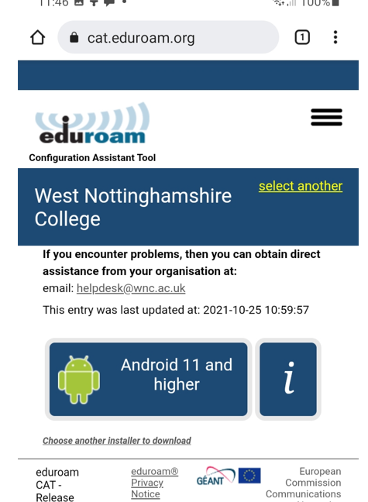
Once the file is downloaded open it with the Eduroam cat app from the play store and select install
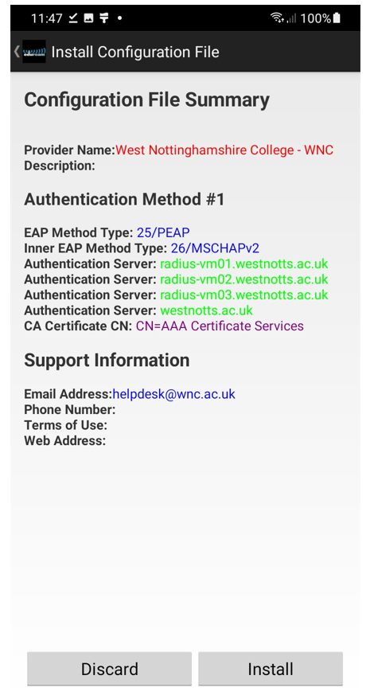

Then enter your username @westnotts.ac.uk (eg. Abc2021000@westnotts.ac.uk) and use your regular password.
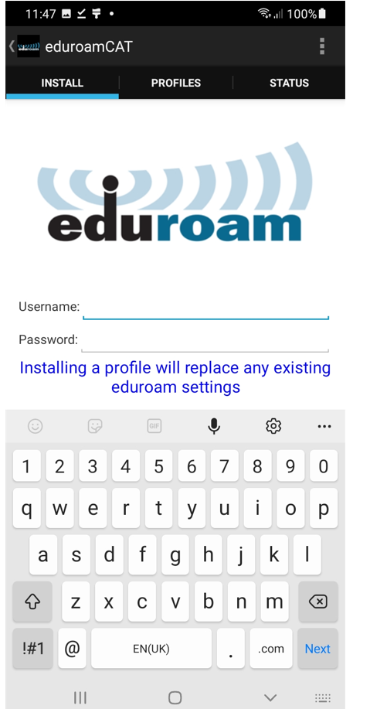

Adding the College Certificate
This may vary depending on the version of android and model of phone

Download the College certificate from https://wnc.ac.uk/ssl-cert
Open settings
Go to security
Go to encryption and credentials and install from storage
Select CA certificate
Accept the warning and if required enter your pin
Browse to the downloaded file and select it
If you are prompted for a certificate name use “sslinspection.crt”

