AD self-service plus app – required for vpn

Setting up the app
- On your mobile device download the AD Self Service plus app from your device’s app store
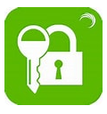
- On your computer browse to https://mfa.wnc.ac.uk:9251 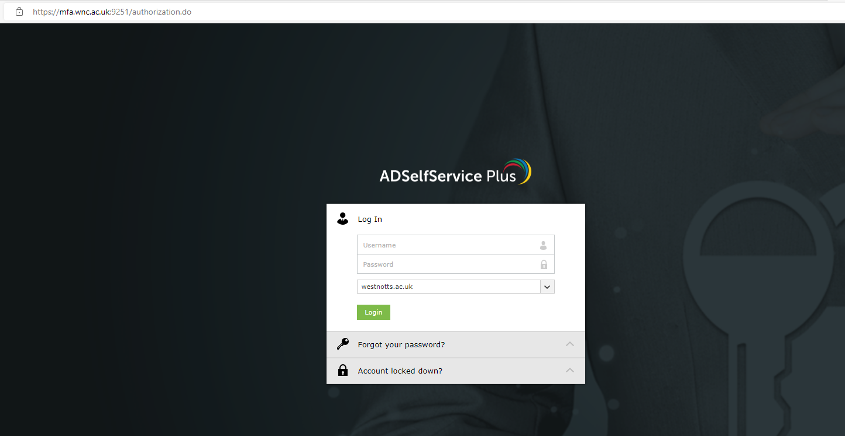
- Sign in with your college username (abc102345) and password. Use your regular mfa method to log in.
- Once signed in, on the top right of the page click on your user icon and mobile access. 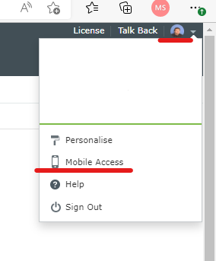
- A screen should then pop up on the web page with a QR code.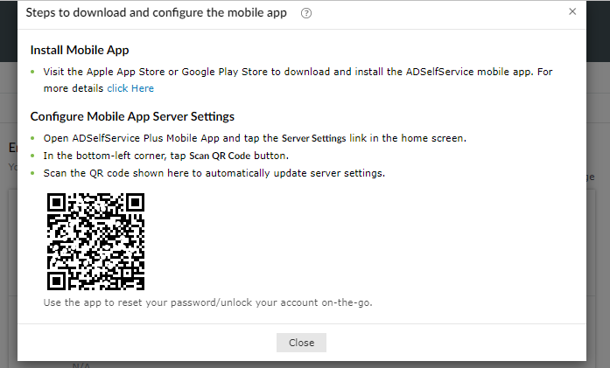
- Switch back to your mobile device and go to the AD self Service Plus app you downloaded earlier.
- Select server settings.
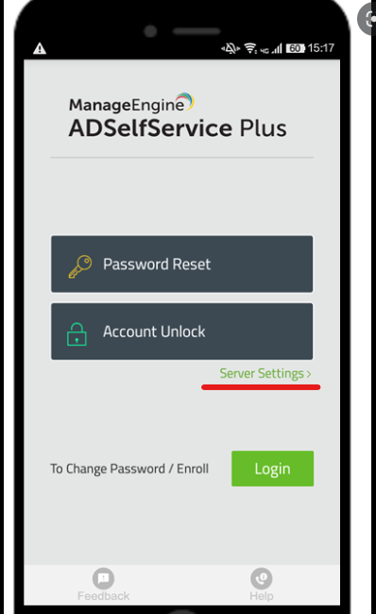
- Select scan QR code at the bottom left. Follow the on-screen instructions to complete the setup and to turn on push notifications. You will need to allow the app to access your camera temporarily.
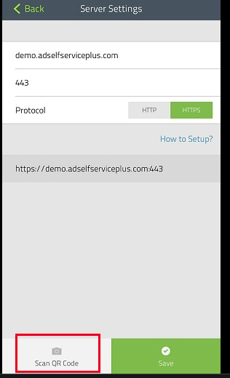
- Once on this screen select the mobile and padlock icon, you might see more icons than this screen shot, turn on push notification and select update on the top right.
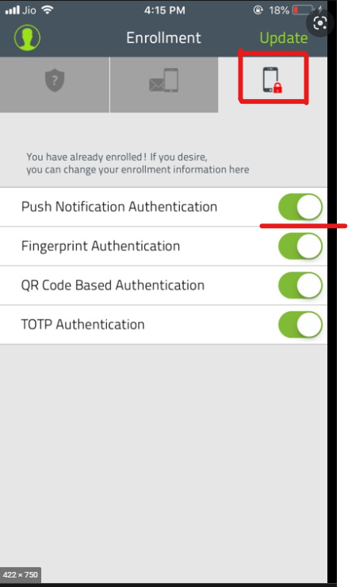
- After this you can close the app and the web page.

Using the VPN
No changes need to be made to the vpn settings on your pc.
When connecting to the vpn and putting in your username and password there will be a pause on screen, during this time your device should give you a push notification to accept onscreen on the mobile device. Do not accept this notification if you are not trying to log in.
Once you accept your computer will complete the vpn sign in and you will be able to work as normal.

