How to use the Microsoft Speak screen reader (for Microsoft Word documents, including if you wish to download the Advice Guide to your own PC as a Word document):

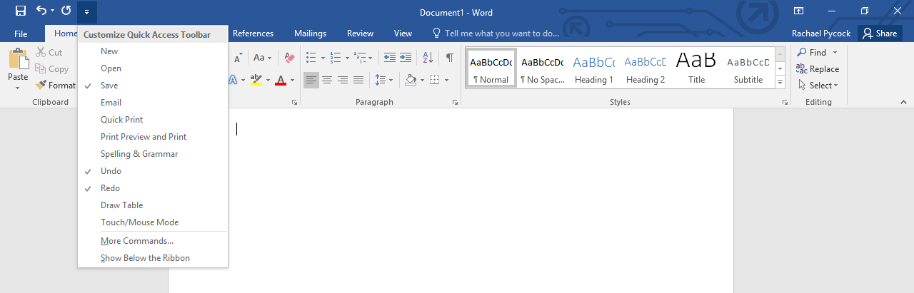
- Click on the little drop-down arrow at the top left hand corner of the screen, just above the ‘Insert’ tab (which is to the right of the ‘Home’ tab). A menu should appear:

- Click on ‘More Commands…’ from this menu:
A dialogue box will appear like the one below:
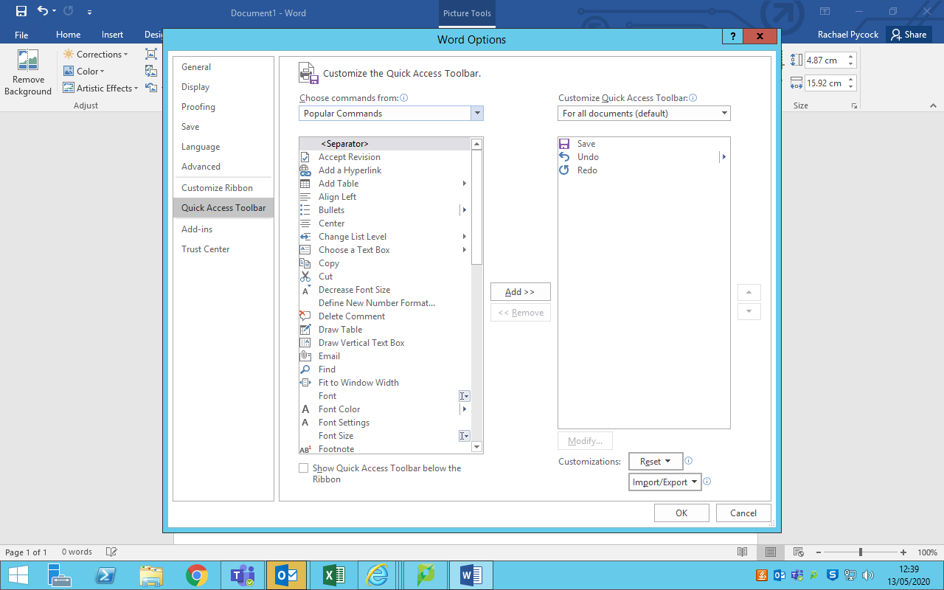

- In the little box where it says ‘Popular Commands,’ click on the drop-down arrow and select ‘All Commands.’
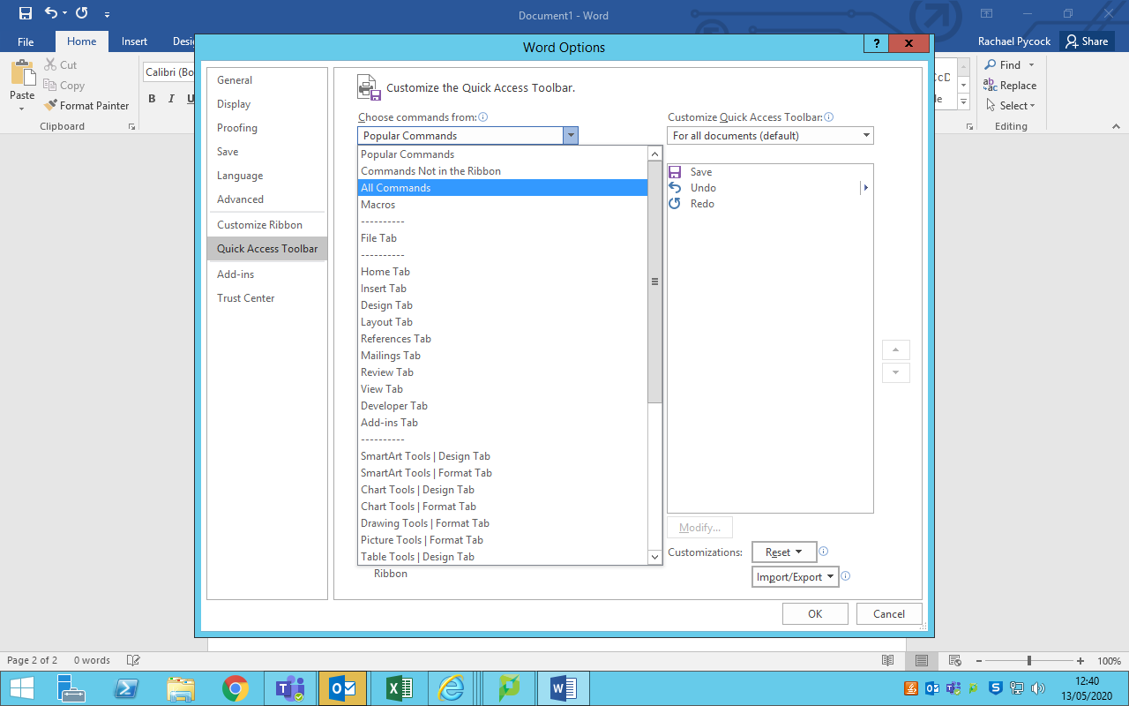

(Please make sure you always click on ‘All Commands,’ as this is the step many people forget when doing this from memory.)

- After clicking on ‘All Commands,’ from the box that appears below, scroll down to select ‘Speak’ from the options (note: it will be quicker to drag the scroll bar down to the ‘s’s, as there are a lot of options!). Click on ‘Speak.’
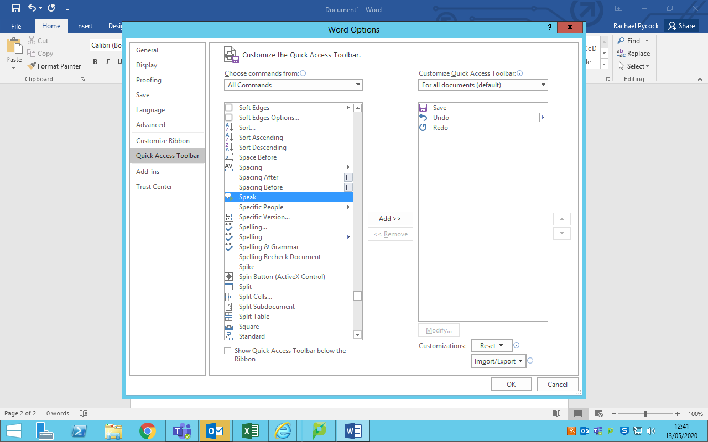

- Once you have clicked on ‘Speak,’ click on the little box in the middle of the screen that says ‘Add >>.’ The Speak function should now be visible in the right hand box. (Double-clicking ‘Speak’ will add it to the right hand box automatically.)
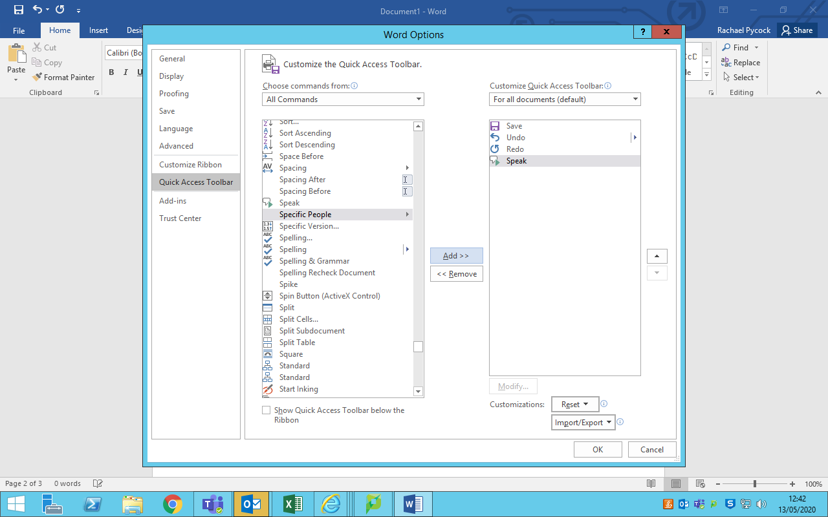

- Click on ‘OK’ at the bottom right of the page. The Word Options box should now disappear. You will now have enabled your document to be read aloud, using the Microsoft ‘Speak’ function.
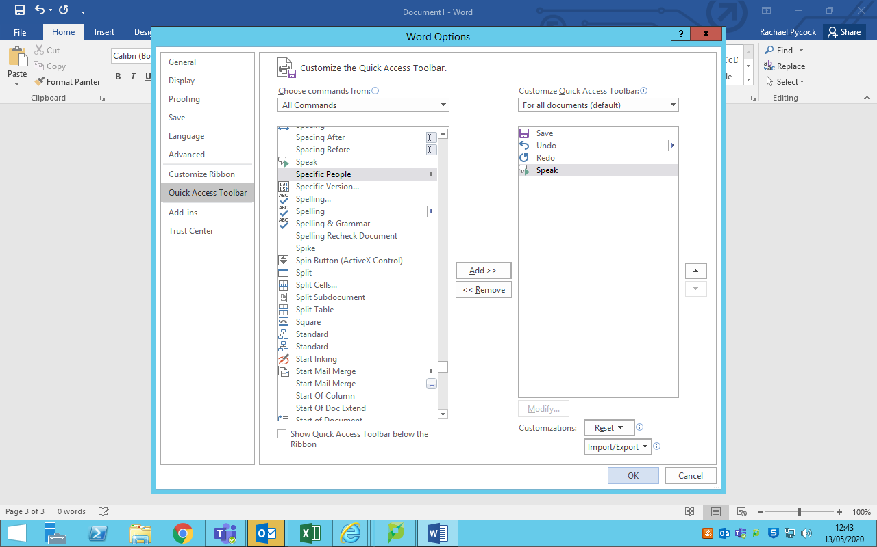

- To have your text read aloud, you will now need to follow these steps:

- Highlight the text to be read aloud;

- Click on the little speech bubble/arrow icon that should be visible just to the left of the little drop-down arrow above the ‘Insert’ tab (the same drop-down arrow that you first clicked on).

Note: if you hover your cursor over the little speech bubble icon, the words ‘speak selected text’ will appear. (The speech bubble icon will be ‘greyed out’ until you highlight some text to be read; the icon will appear after text is highlighted);
- After highlighting the text and clicking the speech bubble icon, you should hear the text being read aloud to you.

Please ensure you have either your PC speakers switched on or are wearing headphones.

