How to use Immersive Reader function – for online Advice Guide attachment:

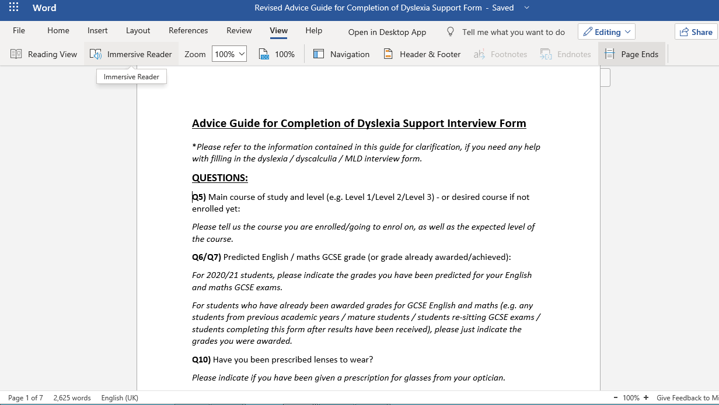
- Click on the ‘View’ tab at the top / middle of the screen.

- Position your cursor (or just click) before the first word of the text.

- Click on ‘Immersive Reader’

- Wait for the Immersive Reader to load. Your screen should look like this (below) after it has loaded.
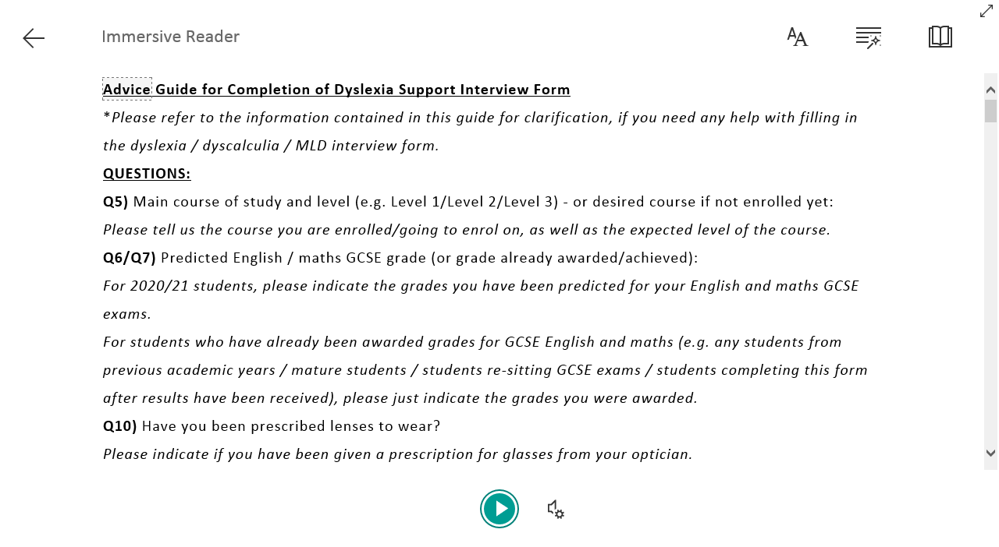

- Click on the ‘Play’ arrow to hear the text read aloud. To change the voice settings, click here.
If you do click on the ‘Voice Settings’ icon, you will see a box like the one below. You can see that changing the voice settings allows you to alter the speed of the voice and whether you hear a male or female voice.
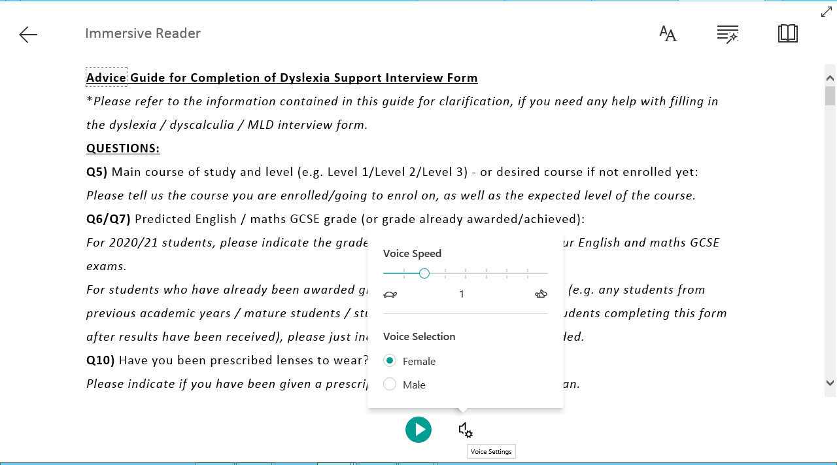

- Clicking in here will give you Text Options

- Clicking here will give you Text Preferences:

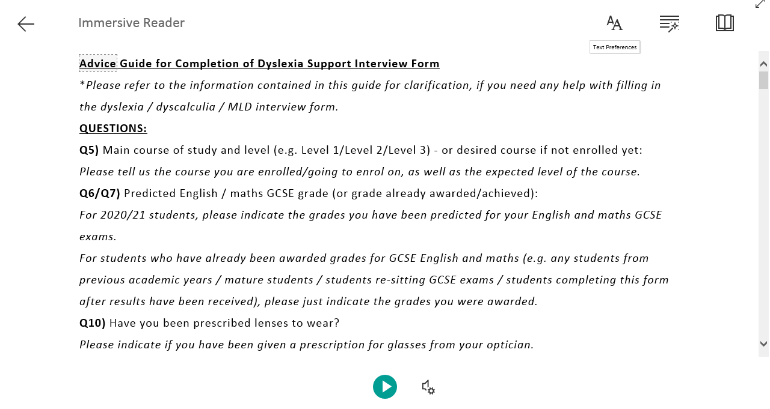

- Text preferences available include changing font, font size, spacing and the colour of the screen (shown below):

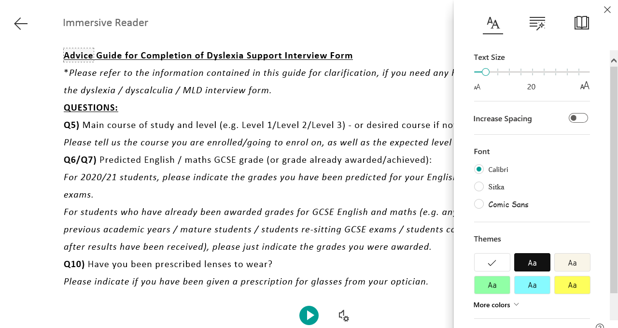

- Clicking here will give you Grammar Options:

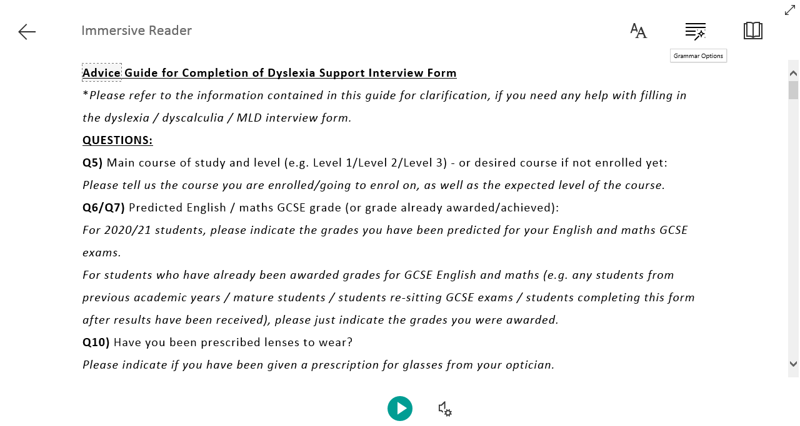

- Grammar options available (shown below) include the option of being able to break a word into its separate syllables (as well as being able to highlights different types of words in different colours, which can be useful in English assignments)
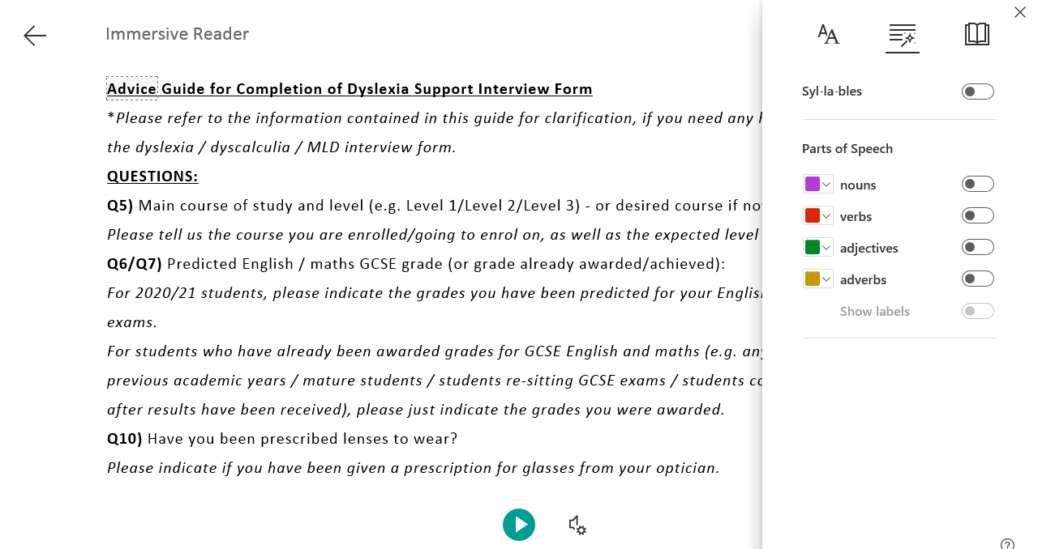

- Clicking here will give you Reading Preferences:

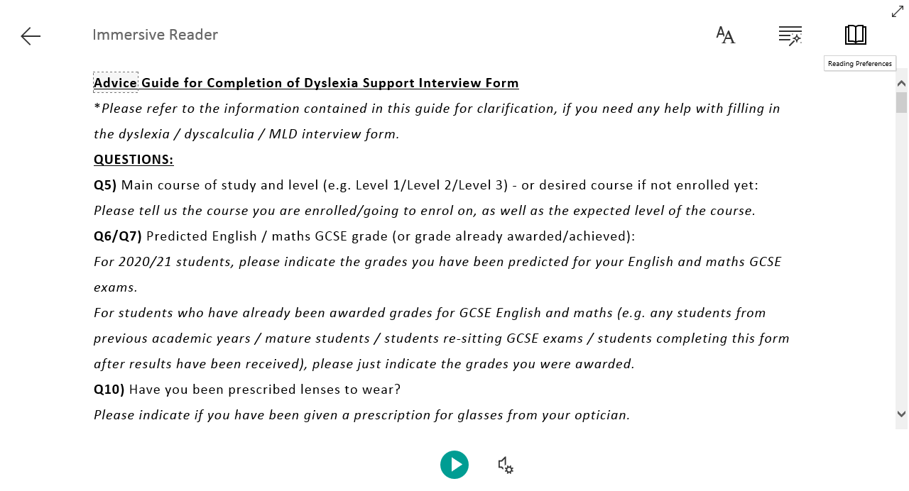
- Reading preferences here include giving you the option to choose whether you want the text to only display each line or paragraph/question, as you read it (the rest of the text is masked). This is under ‘Line Focus’). You can also translate the text into another language.

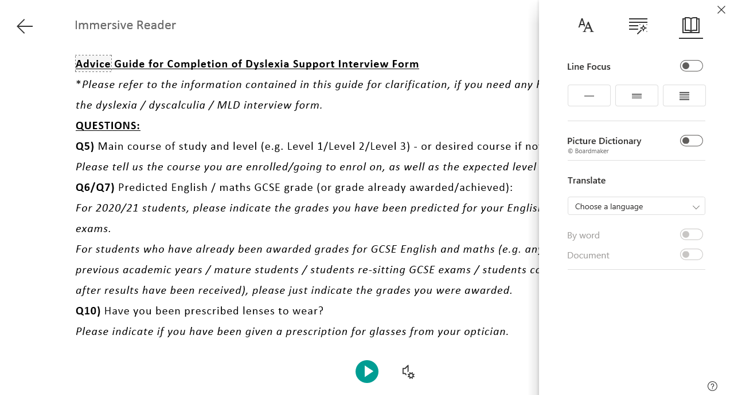

How to use Microsoft Speak (for Microsoft Word documents, including if you wish to download the advice guide to your own PC as a Word document) - screenshot instructions:

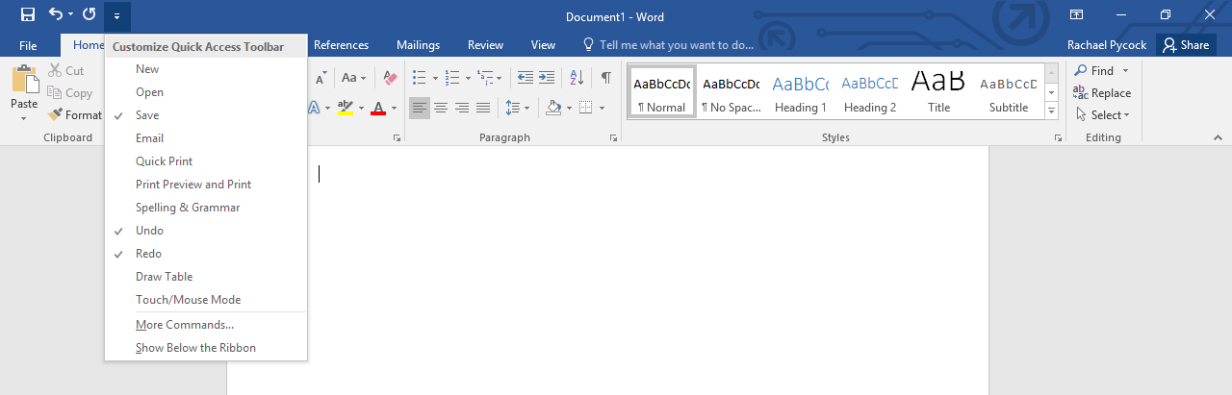
- Click on the little drop-down arrow at the top left hand corner of the screen, just above the ‘Insert’ tab (which is to the right of the ‘Home’ tab). A menu should appear:

- Click on ‘More Commands…’ from this menu:
A dialogue box will appear like the one below:
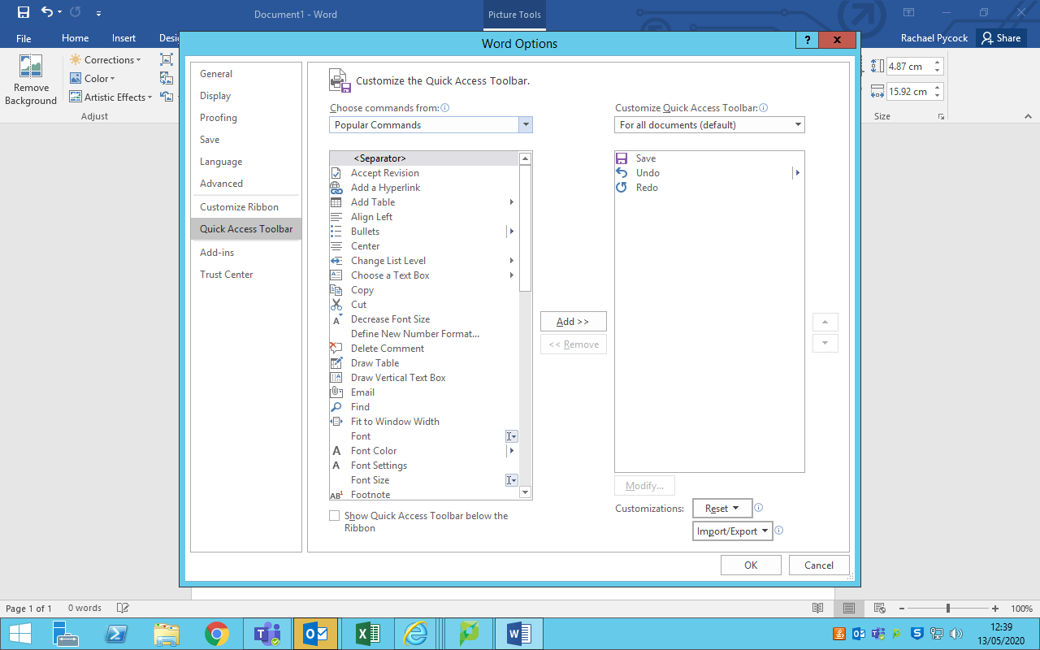

- In the little box where it says ‘Popular Commands,’ click on the drop-down arrow and select ‘All Commands.’
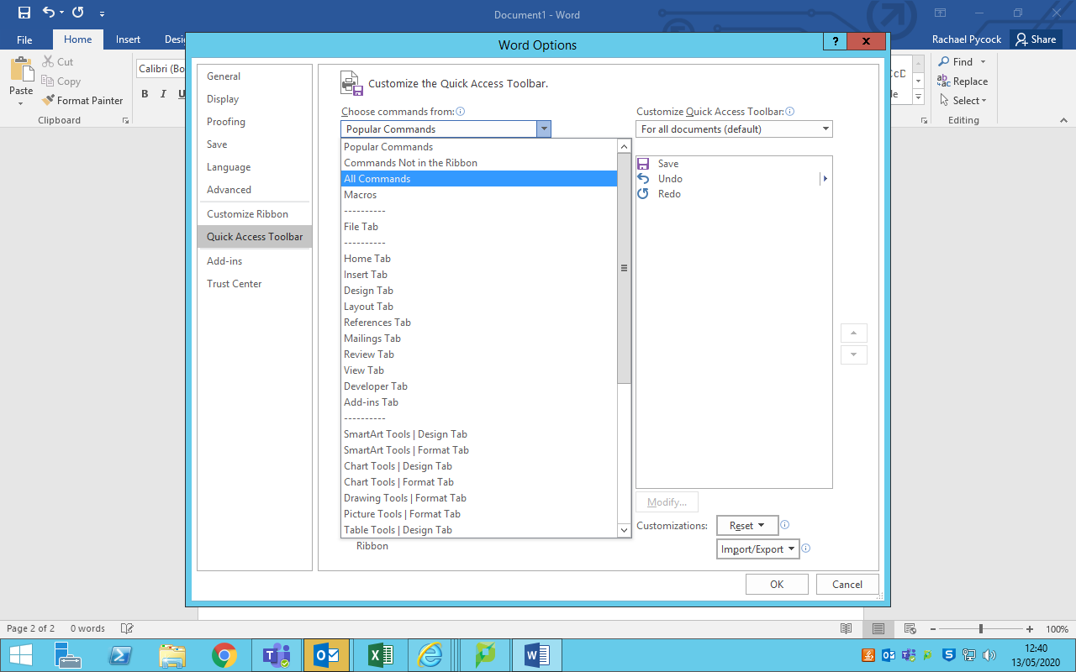

(Please make sure you always click on ‘All Commands,’ as this is the step many people forget when doing this from memory.)

- After clicking on ‘All Commands,’ from the box that appears below, scroll down to select ‘Speak’ from the options (note: it will be quicker to drag the scroll bar down to the ‘s’s, as there are a lot of options!). Click on ‘Speak.’
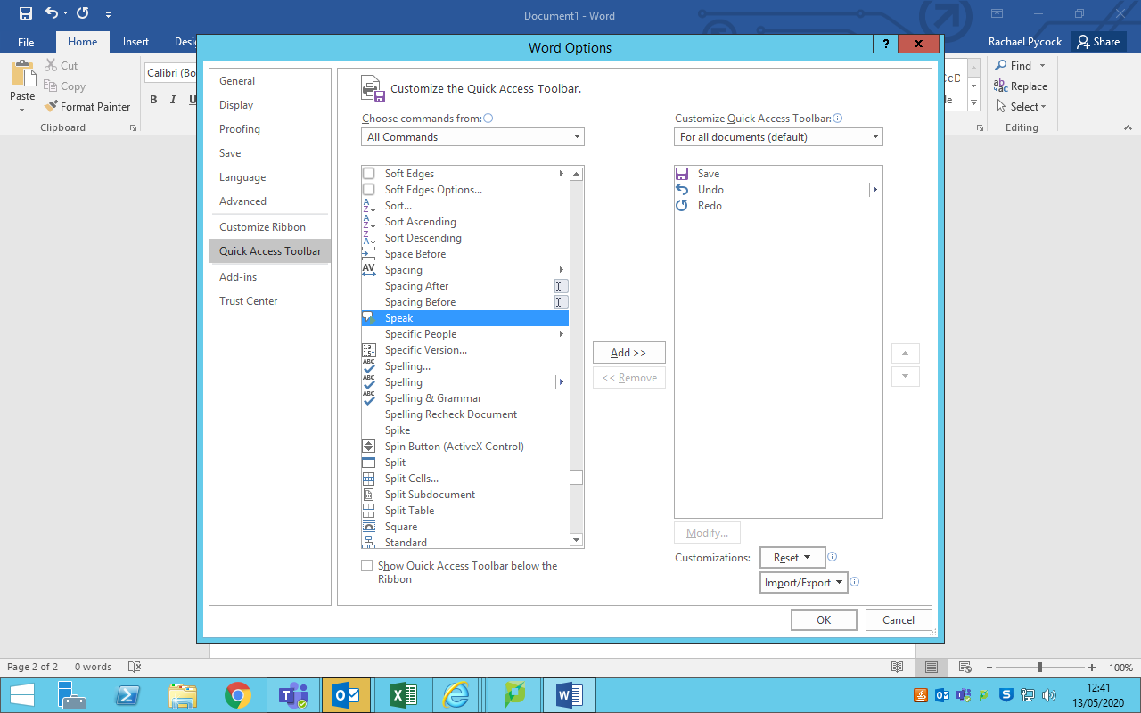

- Once you have clicked on ‘Speak,’ click on the little box in the middle of the screen that says ‘Add >>.’ The Speak function should now be visible in the right hand box. (Double-clicking ‘Speak’ will add it to the right hand box automatically.)
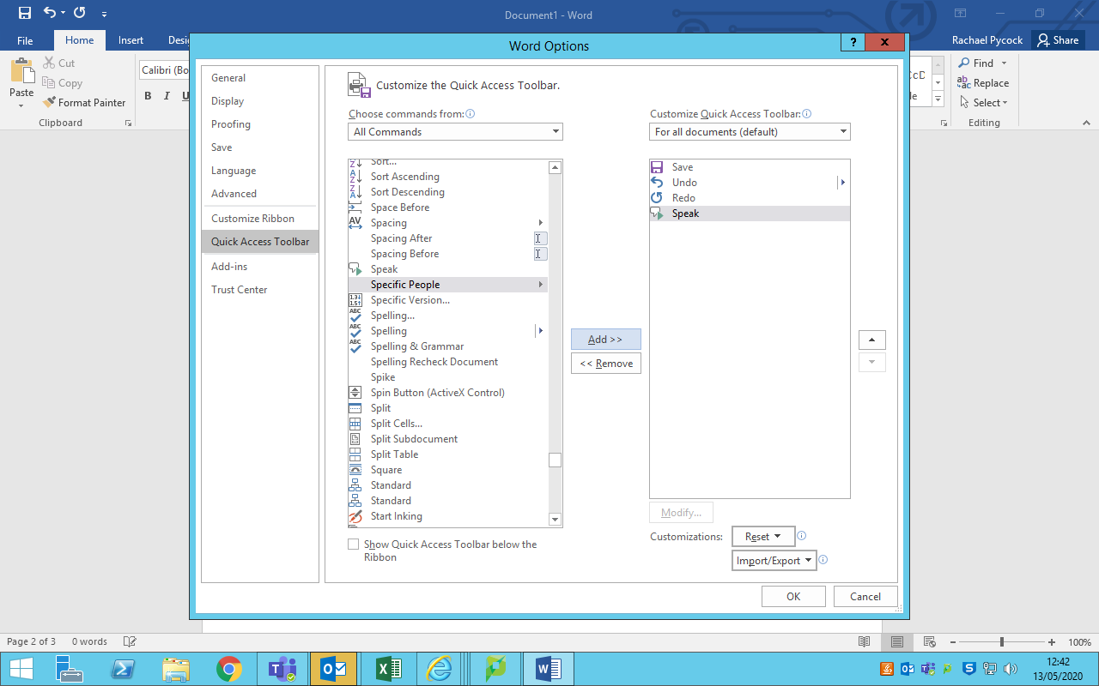

- Click on ‘OK’ at the bottom right of the page. The Word Options box should now disappear. You will now have enabled your document to be read aloud, using the Microsoft ‘Speak’ function.
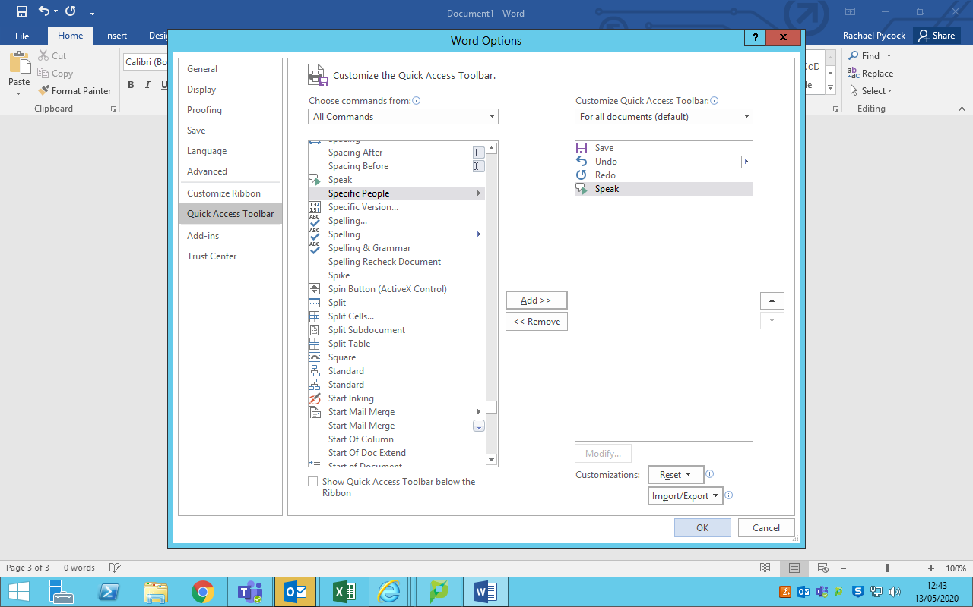

- To have your text read aloud, you will now need to follow these steps:

- Highlight the text to be read aloud;

- Click on the little speech bubble/arrow icon that should be visible just to the left of the little drop-down arrow above the ‘Insert’ tab (the same drop-down arrow that you first clicked on).

Note: if you hover your cursor over the little speech bubble icon, the words ‘speak selected text’ will appear. (The speech bubble icon will be ‘greyed out’ until you highlight some text to be read; the icon will appear after text is highlighted);
- After highlighting the text and clicking the speech bubble icon, you should hear the text being read aloud to you.

Please ensure you have either your PC speakers switched on or are wearing headphones.

